Research on Capital Allowances
HM Revenue and Customs (HMRC)
HMRC Research Report: 782
June 2023

Disclaimer

The views in this report are the author’s own and do not necessarily reflect those of HM Revenue and Customs.

© King’s Printer and Controller of HMSO 2025
This publication is licensed under the terms of the Open Government Licence v3.0 except where otherwise stated. To view this licence, visit nationalarchives.gov.uk/doc/open-government-licence/version/3.
Where we have identified any third party copyright information you will need to obtain permission from the copyright holders concerned.
Published by HM Revenue and Customs, May 2025
Contents
Glossary 4
1 Executive summary 6
Introduction 6
Methodology 6
Summary of findings 6
2 Introduction 9
Background 9
Methodology 9
Reporting conventions 12
3 Awareness and understanding of capital allowances 13
Awareness of capital allowances 13
Understanding of capital allowances 15
Non-claimant awareness and understanding of capital allowances 16
4 Investment behaviour 17
Types of assets invested in 17
Motivations for investing in equipment 18
Value of investments in equipment 18
Funding investments 20
Second-hand assets 21
Non-claimant investment behaviour 22
5 Use of capital allowances 23
Types of capital allowances claimed 23
Decision making process behind claims 24
Super-Deduction claims 25
Non-use of capital allowances 26
6 The influence of the capital allowances on investment behaviour 29
Extent to which capital allowances influence investment 29
Influence of the Structures and Buildings Allowance 31
Influence of the Super-Deduction 32
Influence of hypothetical scenarios 36
7 Disposals and depreciation 40
Disposals 40
Depreciation 41
8 Effects of capital allowances 43
Effect of capital allowances on business growth 43
Providing a roadmap for capital allowance rates 44
9 Appendix 46

Glossary
Annual Investment Allowance (AIA) | A capital allowance that allows a business to deduct 100% of qualifying expenditure on plant and machinery from the business’ profits before tax up to a specified annual limit.
Capital allowance | A type of tax relief which allows the deduction of some or all of the value of an investment from the business’s profits before calculating tax.
Capital expenditure | Money spent by businesses to acquire or improve fixed assets, such as buildings and equipment.
Cashflow | The net balance of cash moving in and out of a business.
Claimants | Businesses that claimed a capital allowance in the 2019 to 2020 tax year.
First Year Allowance (FYA) | A capital allowance designed to incentivise business investments in certain plant and machinery. It allows businesses to claim a percentage (usually 100%) of the cost of qualifying capital expenditure made in the same tax year as the claim.
First Year Allowance (FYA) 50% special rate | The 50% first-year allowance (FYA) for special rate is a new type of first-year allowance, providing relief of 50% on qualifying special rate plant and machinery
Incorporated business | A business registered as a limited company; a legal entity separated from those who own it or run it. The members of limited companies have their liability limited by shares for profit making companies, or by guarantee usually for ‘not for profit’ organisations.
Large business | 250 or more employees or more than £50 million turnover.
Medium business | 50 or more employees or more than £10 million turnover.
Micro business | Fewer than 10 employees and £2 million turnover or less.
Non-claimants | Businesses that had either never claimed a capital allowance or had claimed one prior to the 2019 to 2020 tax year.
Plant and machinery | Items kept for use in a business. Examples include, machinery and tools, IT equipment, office equipment.
Plant and machinery Allowances (PMAs) | A general term for capital allowances relating to plant and machinery investments
Research & Development Allowances (RDAs) | A capital allowance which allows businesses to claim 100% of capital expenditure on research and development incurred in the same tax year.
Small business | Fewer than 50 employees and £10 million turnover or less.
Structures and Buildings Allowance (SBA) | A capital allowance which allows businesses to claim tax relief on investments relating to construction works for non-residential structures and buildings.
Super-Deduction | A capital allowance which offers a 130% first-year allowance on qualifying main rate plant and machinery investments and a 50% first-year allowance for special rate assets until 31 March 2023.
Tax relief | A way of deducting business expenses from gross income in a tax year. Examples include the SME Research & Development (R&D) relief and Patent Box.
Unincorporated business | A sole trader, trustee or partnership that is not incorporated and is subject to income tax on its business profits.
Writing Down Allowances (WDAs) | A capital allowance which spreads tax relief over multiple years by allowing businesses to deduct a percentage annually from a relevant pool of qualifying capital expenditure to arrive at taxable profits. Most expenditure is added to either the main pool or the special rate pool, where WDAs are available at 18% and 6% respectively.

Executive summary

Introduction
  - HMRC Commissioned Ipsos to undertake research on Capital Allowances. Capital allowances provide tax relief for qualifying capital expenditure by reducing taxable profits. Businesses can generally claim capital allowances on assets that are kept for use in the business. Examples include, but are not limited to, IT equipment, machinery, buildings and structures, business vehicles and construction plant.
  - This research was undertaken as part of HM Revenue and Customs’ (HMRC) wider tax relief evaluation programme. The overarching aim of the research was to improve HMRC’s understanding of how businesses use capital allowances. The specific objectives of the evaluation were to:
  - explore and quantify expenditure on different types of assets and disposal of assets
  - explore the process of claiming capital allowances
  - understand how the Super-Deduction capital allowance is impacting investment decisions
  - explore decisions for not claiming capital allowances

Methodology
  - To meet the objectives outlined above, a mixed-method research approach was adopted. This consisted of:
  - a quantitative telephone survey of 940 businesses that claimed capital allowances in the 2019 to 2020 tax year
  - qualitative depth interviews with 29 claimant businesses that participated in the quantitative survey
  - qualitative depth interviews with 11 businesses that did not claim capital allowances in the 2019 to 2020 tax year, but made investments in eligible assets

Summary of findings

Expenditure on different types of assets and disposal of assets
  - The top three most common types of assets eligible for capital allowances that claimant businesses invested in were IT equipment (63%), office equipment (46%) and machinery and tools (39%). Claimants had often invested in multiple qualifying assets for capital allowances, with 71% of businesses having invested in at least two.
  - The mean overall investment in assets eligible for capital allowances was £278,580 and the median spend was £10,000. The highest value investments were made in construction plant (mean value of £785,280 and median value of £15,000) and buildings and structures (mean value of £627,300 and median value of £20,000). The lowest value investments were made in IT equipment (mean value of £9,610 and median value of £2,000) and office equipment (mean value of £3,750 and median value of £1,000).
  - Three quarters (74%) of claimant businesses used only internal funds for investments, while a fifth (20%) utilised a combination of business funds and borrowing. One in twenty (5%) borrowed the full amount invested.
  - A fifth (20%) of claimants disposed of assets in 2019 to 2020. The mean value of assets disposed of in 2019 to 2020 was £104,340 and the median value was £5,000. Two-thirds (66%) of claimants had sold the assets they had disposed of and almost half (47%) had scrapped or destroyed assets. Around a fifth (18%) used a combination of selling and scrappage.

The process of claiming capital allowances
  - Despite being aware that a capital allowance was claimed in 2019 to 2020, close to half (48%) of claimants were unable to recall the name of the capital allowance they claimed. Where businesses were able to recall which capital allowance they claimed, the most common was the Annual Investment Allowance (29%), followed by the main rate of Writing Down Allowances (19%) and Research and Development Allowances (12%).
  - Qualitative interviews uncovered that most claimant businesses were not directly involved in the decision to claim capital allowances in 2019 to 2020. They knew that capital allowances were available and wanted to claim them to reduce their tax bill and maintain cash flow, but they tended to outsource the identification of relevant capital allowances and the associated administrative work to third parties due to a lack of time or expertise, or a mixture of the two.

How the Super-Deduction capital allowance is impacting investment decisions
  - Around a quarter (24%) of businesses were aware of the Super-Deduction. Amongst incorporated businesses there was considerable difference in awareness depending on business size; only 22% of micro businesses were aware of the Super deduction compared to 67% of large businesses.
  - Of all business that were aware of the Super-Deduction, close to half (46%) had claimed it or planned to claim it on investments made in 2021 to 2022 and two-fifths (42%) intended to claim it on investments planned for 2022 to 2023. This means that 11% of all businesses had claimed or planned to claim the Super-Deduction in 2021 to 2022 and 10% of all businesses planned to claim the Super-Deduction in 2022 to 2023. Amongst incorporated businesses, large businesses were more likely than micro businesses to intend to claim the Super-Deduction in 2022 to 2023. There was no difference by size in terms of claiming the capital allowance in 2021 to 2022.
  - The introduction of Super-Deduction had an influence on the investment behaviour of around a fifth (19%) of businesses that had claimed or planned to claim it in 2021 to 2022. Specifically, 12% of those that had claimed or planned to claim the Super-Deduction had brought investments forward, 9% had made investments that were previously unplanned and 6% had invested a higher amount than planned.
  - The introduction of Super-Deduction had an influence on the investment behaviour of around a third (29%) of businesses that planned to claim it in 2022 to 2023. Specifically, 26% of those that planned to claim the Super-Deduction had brought investments forward, 11% had invested a higher amount than planned and 5% had made previously unplanned investments.
  - When presented with hypothetical scenarios about other capital allowances and asked to what extent they would have an influence on investment spend, only a minority of claimant businesses said they would cause them to spend more on investments. The two most impactful scenarios were full expensing being introduced to allow businesses to write off the costs of qualifying investment in one go (36%) and an additional FYA being introduced to bring the overall amount that can be claimed to greater than 100% of the initial cost (35%).

Decisions for not claiming capital allowances
  - Non-claimant businesses did not claim capital allowances in 2019 to 2020 despite making investments in qualifying assets due to three main reasons: small scale investments, limited awareness or understanding of capital allowances and loss-making.
  - Claimant businesses that were aware of the Super-Deduction but did not claim or plan to claim it typically attributed this to no investments being planned in the timeframe the capital is available (before March 2023). Others did make investments in 2021 to 2022 or intended to in 2022 to 2023, but these investments were in asset types that did not qualify for the Super-Deduction. For example, second-hand equipment and buildings and structures.
  - Amongst claimant businesses that invested in buildings and structures but did not claim the Structures and Building Allowance (SBA) in 2019 to 2020, many were unaware that this capital allowance existed. Amongst those aware of the SBA, some had not claimed it because the nature of their investment did not meet the eligibility criteria. Others said they had claimed alternative capital allowances because they had identified them as more appropriate or because their tax agent or accountant had advised them to.

Introduction

Background

  - Capital allowances provide tax relief for qualifying capital expenditure by reducing taxable profits. Businesses can generally claim capital allowances on assets that are used for business purposes. Examples of assets that qualify for capital allowances include IT equipment, machinery, buildings and structures, business vehicles and construction plant.
  - There are two main categories of capital allowances: Plant and Machinery Allowances (PMAs) and Structures and Buildings Allowance (SBAs). The latter provide a flat rate of relief of 3% per year for business spend on commercial buildings and structures. There are a range of different PMAs available with varying rates of relief depending on the type of assets purchased. Examples of plant and machinery allowances available at the time of writing include the Annual Investment Allowance (AIA), First Year Allowances (FYAs) and Writing Down Allowances (WDAs).
  - This research was undertaken as part of HM Revenue and Customs’ (HMRC) wider tax relief evaluation programme. The overarching aim of the research was to improve HMRC’s understanding of how businesses use capital allowances. The specific objectives were to:
  - explore and quantify expenditure on different types of assets and disposal of assets
  - explore the process of claiming capital allowances
  - understand how the Super-Deduction capital allowance is impacting investment decisions
  - explore decisions for not claiming capital allowances

Methodology
  - To meet the objectives outlined above, a mixed-method research approach was adopted. This consisted of:
  - a quantitative telephone survey of 940 businesses that claimed capital allowances in the 2019 to 2020 tax year
  - qualitative depth interviews with 29 claimant businesses that participated in the quantitative survey
  - qualitative depth interviews with 11 businesses that did not claim capital allowances in the 2019 to 2020 tax year, but made investments in qualifying assets

Quantitative fieldwork
  - The sample used for quantitative fieldwork with claimant businesses was provided to IFF Research by HMRC in June 2022. It included the details of businesses that were known to have claimed capital allowances in the 2019 to 2020 tax year.
  - Mainstage survey fieldwork with claimants took place between July and September 2022. Prior to the commencement of mainstage fieldwork all sampled businesses were sent a letter by post notifying them of the research and providing them an opportunity to opt-out of the survey. The letter was accompanied by a data sheet to help businesses prepare for interviews.
  - A total of 940 Computer Assisted Telephone Interviews (CATI) were completed with businesses that claimed a capital allowance in 2019 to 2020. This included 833 incorporated businesses and 107 unincorporated businesses. All interviews were conducted with business representatives involved in making capital investments and claiming capital allowances. These representatives included business owners, managing directors and finance directors. Table 2.1 presents the profile of survey completes in terms of size and sector. On average, the survey took 22 minutes to complete.
Table 2.1 Achieved surveys with claimants by size and sector
 | Micro | Small | Medium | Large | Total
Manufacturing | 35 | 39 | 46 | 22 | 142
Construction, water supply, mining and quarrying | 44 | 17 | 37 | 17 | 115
Wholesale and retail | 46 | 34 | 28 | 21 | 129
Transportation and storage | 11 | 14 | 21 | 10 | 56
Accommodation and food service activities | 12 | 15 | 2 | 5 | 34
Information and communication | 44 | 10 | 10 | 3 | 67
Financial and insurance activities | 22 | 6 | 13 | 9 | 50
Professional, scientific and technical activities | 106 | 13 | 18 | 7 | 144
Administrative and support service activities | 29 | 7 | 22 | 10 | 68
Other | 69 | 25 | 20 | 21 | 135
Total | 418 | 180 | 217 | 125 | 940
  - The data collected in the mainstage survey of claimant businesses was weighted to make it representative of the underlying population of incorporated claimants in terms of size and sector. It was not possible to weight the achieved survey sample of unincorporated claimants to make it representative of the underlying population in terms of size and sector due to insufficient information about the characteristics of unincorporated claimants.
  - Further detail on the methodological approach to the survey of claimant businesses is included in the technical report.

Qualitative fieldwork

Claimants
  - Claimant businesses were recruited for qualitative fieldwork from a sample of those consenting to contact for further research in the main quantitative survey, targeting those whose answers suggested they would be particularly suited to answer questions in the specific areas of interest to the research.
  - Qualitative interviews with claimant businesses took place between August and October 2022. In total, 29 qualitative interviews were conducted. Table 2.2 presents the profile of achieved qualitative interviews with claimants by agreed groups of interest. Please note that the figures presented in Table 2.2 do not sum to 29 because the groups presented are not mutually exclusive.
Table 2.2 Achieved qualitative interviews with claimants by groups of interest
Group | Interviews
Micro | 4
Small | 9
Medium | 9
Large | 7
Do not use an agent for all or most tax matters | 14
Purchased second hand assets | 9
Did not claim max capital allowance available | 6
Invested in structures or buildings but did not claim the SBA | 3
Able to comment on the influence of the SBA | 13
Able to comment on influence of Super-Deduction | 8
Disposed of assets | 15
Total | 29
  - All qualitative interviews were conducted remotely, either by telephone or video call (via Microsoft Teams). On average, each interview lasted 60 minutes.
  - Further detail on the methodological approach to qualitative interviews with claimant businesses is included in the technical report.

Non-claimants
  - Non-claimant businesses were recruited for qualitative fieldwork from a sample of businesses that did not claim capital allowances in the 2019 to 2020 tax year, provided to IFF Research by HMRC in August 2022.
  - Prior to recruitment, all sampled businesses were sent a letter by post notifying them of the research and providing them an opportunity to opt-out of the survey. Non-claimant businesses were then screened to ensure those recruited had made investments in 2019 to 2020 that qualify for capital allowances.
  - Qualitative interviews with non-claimant businesses took place between August and October 2022. In total, 11 qualitative interviews were conducted. All interviews were conducted with business representatives involved in making capital investments. Table 2.3 presents the profile of achieved qualitative interviews with non-claimants by agreed groups of interest. Please note that the figures presented in Table 2.3 do not sum to 11 because the groups presented are not mutually exclusive.

Table 2.3 Achieved qualitative interviews with non-claimants by groups of interest
Group | Interviews
Micro | 4
Small | 1
Medium | 2
Large | 4
Plan to claim capital allowances on 2019 to 2020 Tax year | 3
Previously claimed capital allowances | 6
Confident in understanding of capital allowances | 7
Total | 11
  - As with claimants, qualitative interviews with non-claimants were conducted remotely, either by telephone or video call. On average, each interview lasted 45 minutes.
  - Further detail on the methodological approach to qualitative interviews with non-claimant businesses is included in the technical report.

Reporting conventions
  - The achieved survey sample of incorporated claimants was weighted to make it representative of the underlying population in terms of size and sector. It was not possible to weight the achieved survey sample of unincorporated claimants due to insufficient information about the characteristics of this group. Consequently, all sub-group analysis has been conducted amongst incorporated businesses only.
  - In this sub-group analysis, all differences noted are significant to a 95% confidence level: by convention, this is the statistical ‘cut off point’ used to mean a difference is large enough to be treated as genuine. This means the significant differences noted throughout this report have a 95% chance of being ‘true’ (due to a genuine difference in the groups being compared, and only a 5% chance that the results are due to chance).
  - Findings from qualitative interviews with claimant and non-claimant businesses are integrated throughout. Quote attributions flag the claimant status, sector and size of business. It should be noted that findings from qualitative fieldwork provide insight into perceptions, feelings, and behaviours rather than quantifiable findings from a statistically representative sample. Because qualitative samples are small and purposively designed, the findings cannot be considered to be representative of the views of all claimants and non-claimants.

Awareness and understanding of capital allowances

  - This chapter focuses on the extent to which claimant businesses were aware of capital allowances and understood them. The chapter concludes with a short section on the awareness and understanding of capital allowances amongst non-claimant businesses.

Awareness of capital allowances

Awareness amongst all screened claimants (unweighted)
  - As explained in Chapter 2, all surveyed businesses were aware they claimed a capital allowance in the 2019 to 2020 tax year. Therefore, results from the completed surveys cannot provide insight into overall awareness levels of capital allowance claims amongst claimant businesses.
  - However, findings from all claimant businesses contacted during fieldwork can be used to provide an indication of awareness. Of the 1,712 claimants that provided sufficient information, almost three quarters (72%) were aware they claimed a capital allowance in the 2019 to 2020 tax year. Among these, over half (56%) were aware of the claim and year the investment was made and 16% were aware of the claim but not the year the investment was made. Just over a quarter (28%) of claimants were unaware of their 2019 to 2020 capital allowance claim. It should be noted that these figures are unweighted and should be treated with caution, as indicative only.

Awareness amongst surveyed claimants
  - When not prompted with the names of capital allowances, around two-fifths (42%) of claimants were aware of at least one type of capital allowance (45% incorporated and 28% unincorporated). As Figure 3.1 shows, the Annual Investment Allowance (AIA) had the highest level of unprompted awareness (20%), followed by general Plant and Machinery Allowances (12%) and Structures and Buildings Allowances (12%).

Figure 3.1 Awareness of capital allowances prompted and unprompted
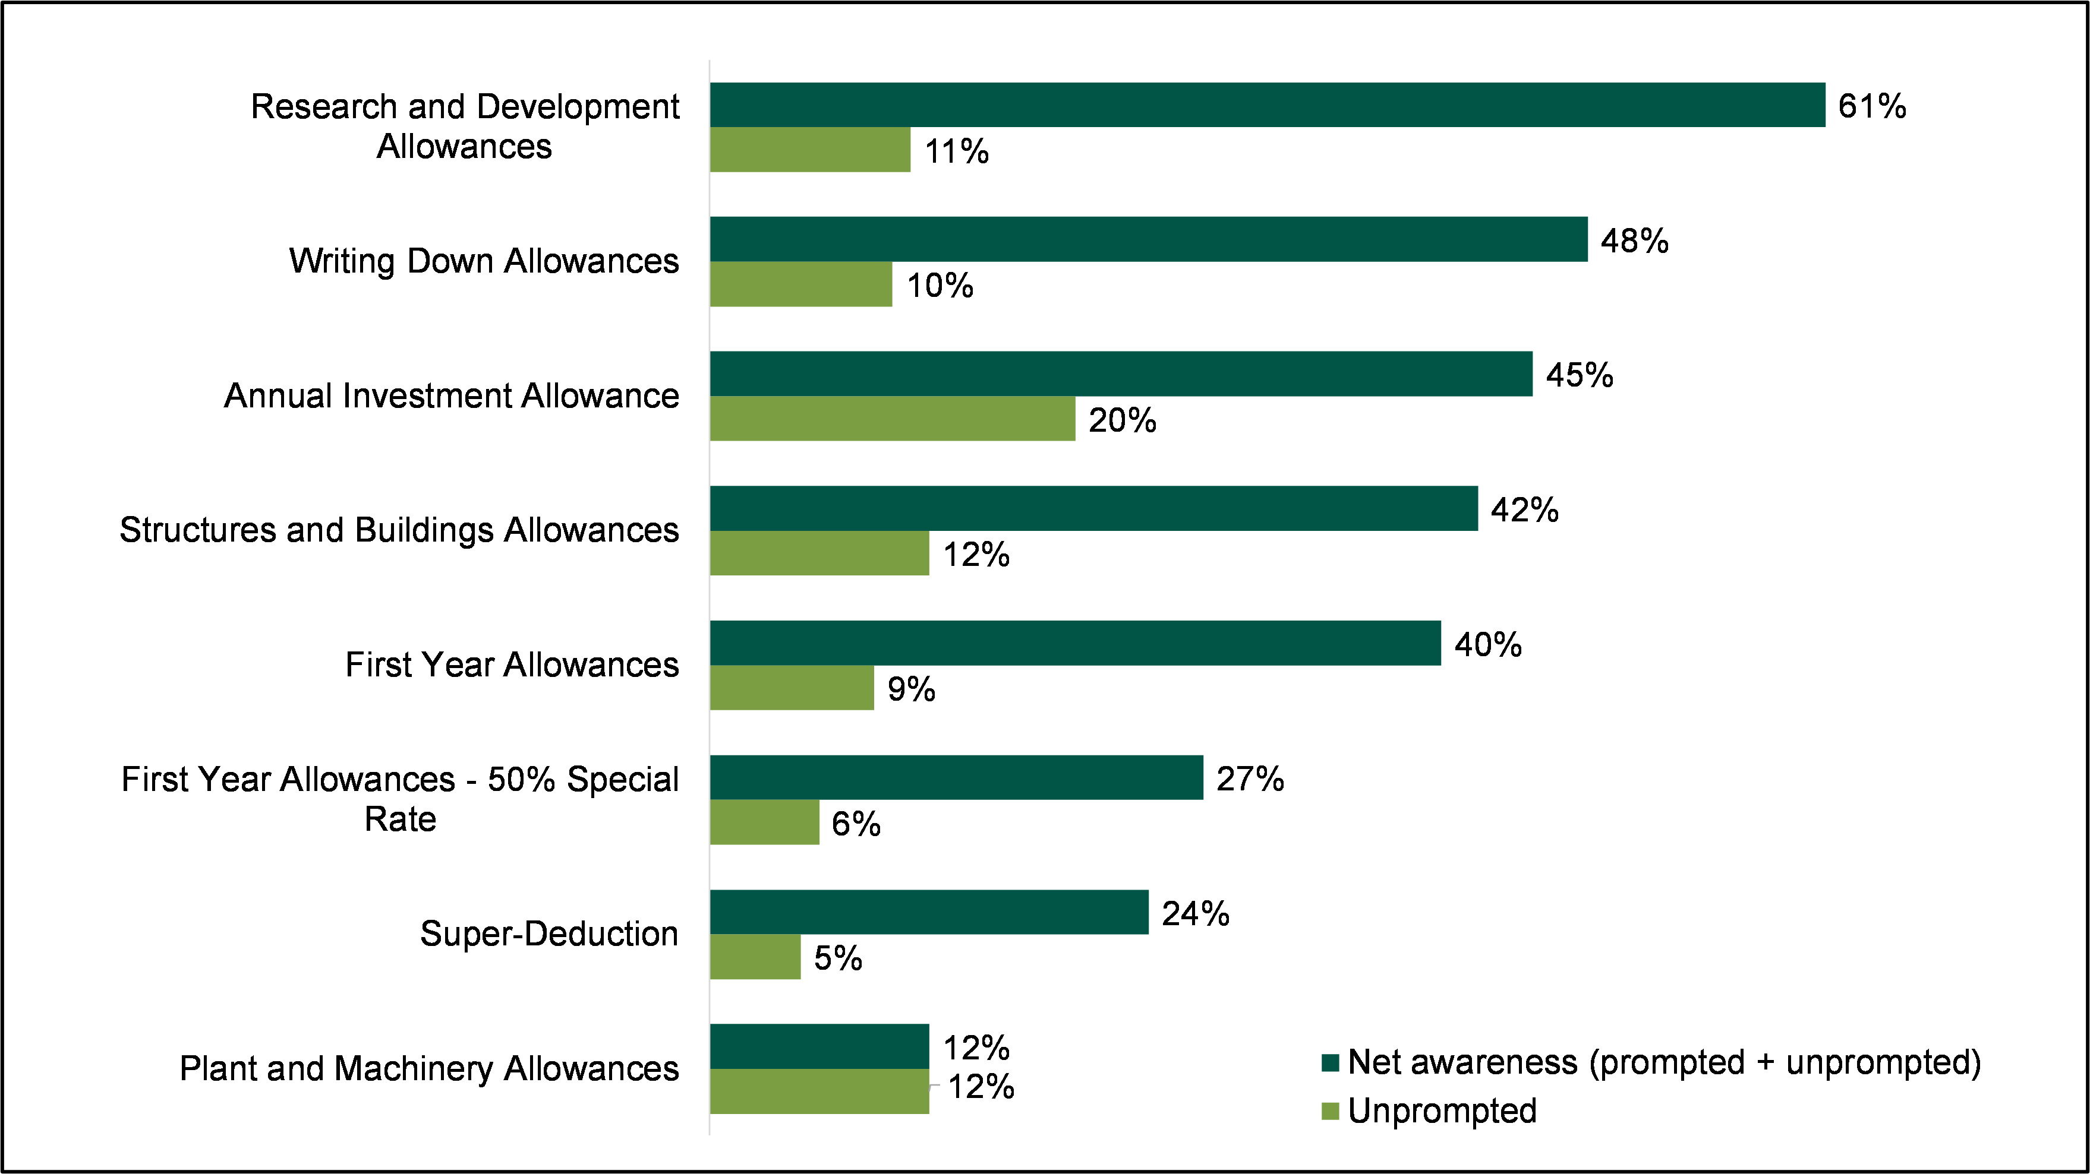S7/S7a/F1: Awareness of capital allowances. Base: All (940)
  - When prompted with the names of capital allowances, the proportion of claimants aware of at least one type increased to over four-fifths (83%; 72% unincorporated and 85% incorporated). As presented in Figure 3.1, Research and Development Allowances (RDAs) had the highest level of net awareness (61%), followed by Writing Down Allowances (WDAs) (48%) and the AIA (45%). Around a quarter (24%) of businesses were aware of the Super-Deduction capital allowance.
  - Amongst incorporated businesses, medium-sized and large businesses were more likely than their smaller counterparts to be aware of each capital allowance. Focusing on the top three presented in Figure 3.1, 90% of medium-sized businesses and 88% of large businesses were aware of RDAs; 80% of medium-sized businesses and 90% of large businesses were aware of WDAs; and 78% of medium-sized businesses and 82% of large businesses were aware of the AIA. By comparison, amongst micro businesses 60% were aware of RDAs, 43% were aware of WDAs and 41% were aware of the AIA. A breakdown of awareness by business size amongst incorporated businesses is presented in Table 3.1.

Table 3.1 Awareness of capital allowances by business size, incorporated businesses
 | Micro | Small | Medium | Large | All
Research and Development Allowances (RDAs) | 60%** | 72% | 90%* | 88%* | 65%
Writing Down Allowances (WDA) | 43%** | 58% | 80%* | 90%* | 50%
Annual Investment Allowance (AIA) | 41%** | 55% | 78%* | 82%* | 48%
Structures and Buildings Allowances (SBAs) | 39%** | 47% | 51%* | 65%* | 43%
First Year Allowances (FYA) | 33%** | 49%* | 74%* | 82%* | 41%
50% Special Rate FYA | 22%** | 37%* | 59%* | 62%* | 29%
Super-Deduction (SD) | 20%** | 33% | 47%* | 67%* | 26%
Plant and Machinery Allowances (PMAs) | 12% | 7% | 16% | 22%* | 11%
Unaware of Capital Allowances | 18%* | 13% | 5%** | 3%** | 15%
S7/S7a/F1: Awareness of capital allowances. Base: All incorporated businesses (833), Micro (312), Small (179), Medium (217), Large (125). ** denotes significantly lower than the average, * denotes significantly higher than the average.
  - Awareness of capital allowances also varied by sector. Incorporated businesses in the professional, scientific, and technical activities sector were more likely than average to be aware of all capital allowances. Focusing on the top three presented in Figure 3.1, 82% were aware of RDAs, 62% were aware of WDAs and 60% were aware of AIA. By contrast, businesses in the transportation and storage sector had a lower rate of awareness when compared to others (48%).
  - The use of tax agents or accountants had a considerable influence over awareness. Around a fifth (18%) of incorporated businesses that used a tax agent or accountant for all or most of their tax affairs were unaware of any capital allowances by name compared to just 2% of those that used agents for occasional advice.
  - Qualitative interviews with claimant businesses discovered that many had become aware of capital allowances via a tax agent or accountant. Only in a few instances had businesses become aware of capital allowances through alternative channels. These included through government announcements and coverage in the media.
“It would have been at the agent’s suggestion. I think he just thought this was the most sensible one, and the most logical one to go for.”
Claimant, Information and Communication, Micro
“The agent goes through accounts at the end of the tax year and looks at what was spent. Retrospectively they will bring up aspects in which tax could be less if they go through certain processes.”
Claimant, Wholesale and Retail, Small

Understanding of capital allowances
  - Qualitative interviews found that many claimant business representatives had a limited understanding of available capital allowances, even if aware of them by name. They were typically heavily involved in investment decisions but relied on the expertise of tax agents and accountants to identify relevant capital allowances and action claims. Some explained that they were too busy with the day-to-day operations of the business to develop an understanding of capital allowances and tax reliefs.
“The actual tax computations are done by our auditors … purchasing decisions I do get involved in so I might tell them when we buy something.”
Claimant, Transportation and Storage, Small
“We spent the money getting the work done and when the accountants did the figures they said you qualify for some capital allowance here … we just let them get on with it!”
Claimant, Wholesale and Retail, Small
  - However, there were some claimant businesses that demonstrated a comprehensive understanding of the capital allowances available, including the rates of relief, limits and eligibility requirements. These tended to be larger businesses with internal resource that could be dedicated to capital allowances and tax reliefs. Some businesses had developed a good understanding of the capital allowance landscape through discussions with tax agents and accountants.
“The AIA is an enhanced deduction, so you get 100% tax relief in your first year up to a certain limit… the rates for SBA are pretty small but it is a tax deduction available so because it is tax deductible we pay less CT… WDAs are just a mechanism for claiming capital allowances and nothing sophisticated there. If you have allowances brought forward that you haven’t all claimed in one year, that balance you can claim in the following year.”
Claimant, Health and Social Work, Large
  - As described earlier, around a quarter (24%) of claimant businesses were aware of the Super-Deduction. Although a relatively low level of awareness, most of those aware of this capital allowance had a good understanding of the rates available. Nine in ten were aware of the rate available for main rate plant and machinery (91%; 88% unincorporated, 91% incorporated) and six in ten were aware of the 50% first-year allowance rate on special rate plant and machinery (60%; 50% of unincorporated businesses, 61% of incorporated businesses).
  - Understanding of the Super-Deduction’s disposal rules was notably lower. Two-fifths (39%) of those aware of the Super-Deduction were familiar with the disposal rules for assets that are claimed under the capital allowance. However, of these, the majority (87%) were confident they understood the rules (see Figure 3.2).
Figure 3.2 Confidence in understanding the Super-Deduction disposal rules amongst those aware of the Super-Deduction Capital Allowance
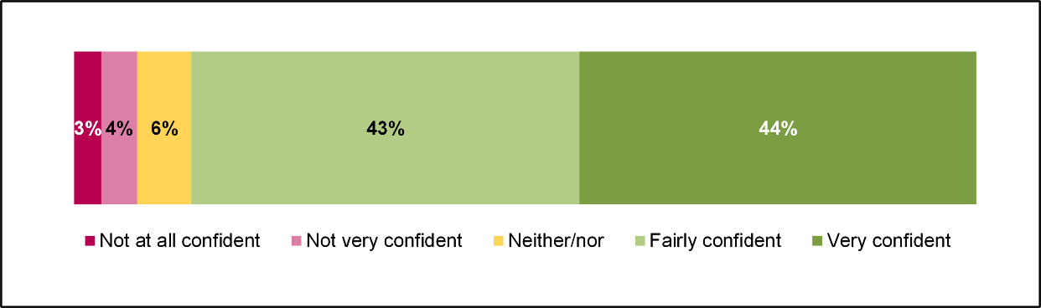
Base: F4: To what extent, if at all, are you confident you understand the disposal rules for assets claimed under the Super-Deduction capital allowance? Base: All aware of Super-deductions prior to interview (325)

Non-claimant awareness and understanding of capital allowances
  - Many non-claimant businesses were aware of the term ‘capital allowances’ but showed minimal awareness of specific capital allowances or an understanding of how they worked or what they could offer. Some said that they did not have the time to dedicate to learning about capital allowances as they were too busy running their businesses. Others said they left tax related matters to their tax agent or accountant.
“I've heard of the term, I've received emails from various places advising me to do this, that and the other with Capital Allowances, but to be honest I never had the time to do anything much about them.”
Non-claimant, Manufacturing, Micro
“I rely on my accountant to know about these things. If I need something for my business, I buy it, give the receipt to my accountant and if the accountant says that’s tax deductible, then it’s tax deductible. If it’s not tax deductible, then I pay the full tax on it.”
Non-claimant, Professional, Scientific and Technical, Micro

  - Where non-claimants were aware of capital allowances, this normally stemmed from conversations with their tax agent or accountant. Like claimants, the AIA was the capital allowance most widely known by non-claimants. Other capital allowances that were spontaneously mentioned included WDAs, FYAs and the Super-Deduction.
“There is a super deduction at the moment for two years and that is of interest to us because we are at a point where some of our assets have been going for a very long time.”
Non-claimant, Professional, Scientific and Technical, Medium

Investment behaviour

  - This chapter addresses the investment behaviour of claimant businesses. Specifically, the chapter covers the types of assets invested in (in the tax year when investments that capital allowances were claimed on in 2019 to 2020 were made), the motivations behind making these investments, the value of investments and how investments were financed. The chapter concludes with a short section on the investment behaviour of non-claimant businesses.

Types of assets invested in
  - As presented in Figure 4.1, the top three most common types of assets eligible for capital allowances that claimants invested in were IT equipment (63%), office equipment (46%) and machinery and tools (39%). IT software also featured prominently (33%). Claimants had often invested in multiple qualifying assets for capital allowances, with 71% of businesses having invested in at least two and 29% having invested in four or more.
Figure 4.1 Types of equipment invested in
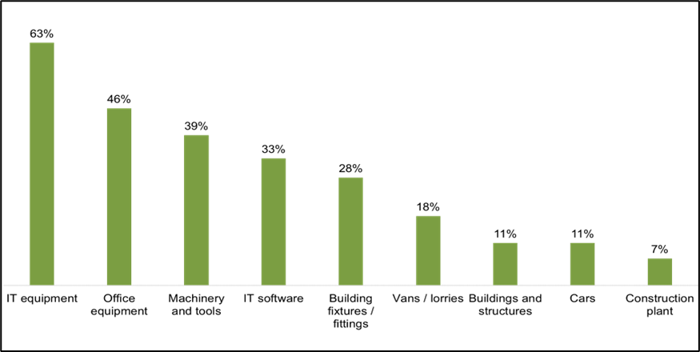
Base: B1: Which of the following types of assets eligible for capital allowances did your business invest in? Base: All businesses (940)
  - The top three types of capital investments made were the same amongst incorporated and unincorporated claimants. However, the order of these top three varied slightly. For incorporated businesses, investments in IT equipment were the most common (67%) while for unincorporated businesses the most common were investments in machinery and tools (49%).
  - Amongst incorporated businesses, business size affected the types of investments made. Large businesses were more likely to invest in all asset types except vans and lorries and construction plant. For instance, 80% of large businesses invested in IT equipment (compared to an average of 67%) and 64% of large businesses invested in office equipment (compared to an average of 48%).
  - Sector also had a notable influence over the types of assets invested in amongst incorporated businesses:
  - IT equipment was more likely to be invested in by businesses in information and communication (85%), and professional, scientific and technical activities (82%), compared to an average of 67%
  - machinery and tools were more likely to be invested in by businesses in manufacturing (74%), compared to an average of 38%
  - IT software was more likely to be invested in by businesses in information and communication (57%), compared to an average of 34%
  - vans and lorries were more likely to be invested in by businesses in transportation and storage (65%) and construction, water supply, mining and quarrying (52%), compared to an average of 18%
  - construction plant was more likely to be invested in by businesses in construction, water supply, mining and quarrying (25%), compared to an average of 7%

Motivations for investing in equipment
  - During qualitative interviews most claimant businesses explained that investments were made to maintain and improve productivity. For example, businesses invested in new IT equipment, cars and machinery because existing assets had become outdated and inefficient. In some cases, the assets invested in were seen as essential and without replacing or upgrading them, businesses would experience higher costs or would not be able to operate.
“If we haven't got the latest versions of MS or Mac operating systems, and all the hardware that goes with that, we are not at the forefront of technology. Our IT spend is very much making sure that all our engineers have got the best equipment.”
Claimant, Transportation and Storage, Large
  - For some businesses, investments were made as part of an expansion strategy or to stimulate growth. For instance, some had invested in new machinery to expand product lines, others had invested in new IT equipment to cater for an enlarged workforce and some had invested in buildings and structures to make room for new facilities.
“Machinery we're buying is to give us additional capacity to move forward and service demand out there in the market.”
Claimant, Manufacturing, Micro
“We were expanding our internal office space; putting in a new mezzanine floor, revamped some of the space below into some R&D space and a medical laboratory."
Claimant, Professional, Scientific and Technical, Medium
  - Finally, some businesses invested in assets to reduce costs. As an example, the claimant business quoted below invested in new machinery to automate production processes to allow them to cut down on labour costs and increase productivity.
“I am trying to keep labour down and train labour up. The machinery gets cleverer and cleverer so with the same amount of people we do a lot more work.”
Claimant, Manufacturing, Micro

Value of investments in equipment
  - As presented in Table 4.1, for claimant businesses that could remember the investments made, the mean overall investment in assets eligible for capital allowances was £278,580 and the median spend was £10,000. Overall, around a quarter (23%) of claimant businesses were unable to recall the value of investments. This was particularly pronounced for buildings and structures (52%), construction plant (42%) and building fixtures and fittings (42%). A full breakdown of the value of investments made by asset type is presented in Table 9.1 in the appendix.

Table 4.1 Average value of investments made by claimants, by asset type
- | Base | Don't know / Refused | Mean (£) | Median (£)
All businesses that could recall investments made | 875 | 23% | £278,580 | £ 10,000
Construction plant | 86 | 42% | £785,280 | £ 15,000
Buildings and structures | 138 | 52% | £627,300 | £ 20,000
Vans and lorries | 211 | 28% | £115,560 | £ 21,000
Machinery and tools | 425 | 32% | £ 96,300 | £ 5,000
Building fixtures and fittings | 338 | 42% | £ 92,670 | £ 5,000
IT Software | 328 | 33% | £ 84,060 | £ 1,000
Cars | 158 | 33% | £ 41,770 | £ 13,000
IT Equipment | 625 | 26% | £ 9,610 | £ 2,000
Office Equipment | 450 | 31% | £ 3,750 | £ 1,000
B2: How much did your business spend on the following assets? Base: All who can recall investments made (see table). NB: averages have been rounded to the nearest £10.
  - Across all asset types, the mean value of investment was higher than the median value of investment, indicating that most businesses invested relatively small amounts, while some businesses invested large amounts. Amongst all businesses, 38% made investments of less than £10,000 and 3% invested more than £500,000.
  - The highest value investments were made in construction plant (mean value of £785,280 and median value of £15,000) and buildings and structures (mean value of £627,300 and median value of £20,000). The lowest value investments were made in IT equipment (mean value of £9,610 and median value of £2,000) and office equipment (mean value of £3,750 and median value of £1,000).
  - Incorporated businesses had a mean investment spend of £311,170 and a median spend of £10,500. The asset type with the highest average investment was construction plant, with a mean value of £1,361,060 and median value of £130,000. Unincorporated businesses had a mean investment spend of £29,810 and a median spend of £3,000. The asset with the highest average investment was buildings and structures, with a mean value of £226,190 and median value of £44,000.
  - Amongst incorporated businesses, large businesses were more likely to make higher value investments. The mean value of investments made by large businesses was £4,740,720 compared to £24,160 among micro businesses.
  - There was also some variation in the value of investments made across incorporated businesses of different sectors. Businesses in the following sectors were more likely than average to have made investments of less than £5,000:
  - information and communication (50% vs 27%)
  - professional, scientific and technical activities (50% vs 27%)
  - administrative and support service activities (44% vs 27%)

Funding investments
  - Investments made by claimant businesses were largely funded through funds held by the business. As illustrated in Figure 4.2, three quarters (74%) of businesses used only internal funds for investments, while a fifth (20%) utilised a combination of business funds and borrowing. One in twenty (5%) borrowed the full amount invested. Totalling the numbers of businesses who funded their investments through business funds only and a combination of business funds and borrowing, 94% of claimant businesses funded investments with at least some funds already held by the business.
Figure 4.2 Funding of investments
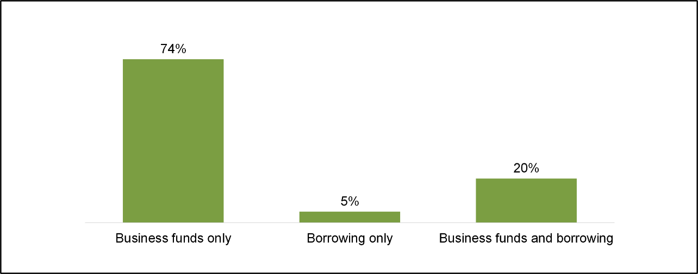
B3: How were investments primarily funded? Base: All who can recall investments made (890)
  - Amongst incorporated businesses, 74% funded their investments through business funds, 5% used borrowing and 21% used both. For unincorporated businesses, 70% used business funds, 11% used borrowing and 17% used both
  - Focusing on incorporated businesses, small businesses were more likely to fund investments at least partly through borrowing (36% vs 25%) while micro businesses were less likely (20% vs 25%). There were no statistically significant differences in the likelihood of medium or large businesses to fund investments through borrowing.
  - There was some variation in the tendency to use on borrowing across sectors. In the transportation and storage sector over half (56%) funded their investments at least partly through borrowing. Meanwhile, businesses that engaged in professional, scientific and technical activities (11%) and financial and insurance activities (4%) were less likely to borrow funds.
  - The value of the investments made also influenced how investments were funded; the higher the sum invested, the greater the likelihood of borrowing. Only 7% of incorporated businesses that had invested less than £5,000 in total used borrowed funds, and this rose to 65% amongst those that had invested over £500,000. Linked to asset value, the types of assets purchased influenced how investments were funded. Investments in vans and lorries (54%), construction plant (45%), cars (45%), machinery and tools (37%) and buildings fixtures and fittings (33%) were more likely to have been funded by some amount of borrowing.
  - During qualitative interviews, claimant businesses that utilised borrowing to fund investments often attributed this to a desire to retain business funds for other purposes (for example, for fixed overheads and other investments). Some reported that favourable interest rates at the time of investment made borrowing an attractive option and a few said that allowed them to spread the cost of investment.
“We didn't want to decrease our liquidity in the company so went for some external finance.”
Claimant, Professional, Scientific and Technical, Medium
“Given the low interest environment it was easier to borrow as it maintained cash for other investments.”
Claimant, Transportation and Storage, Medium
  - In contrast, those who preferred using business funds did so because they had sufficient cash reserves to cover investment spend and wanted to avoid the risks associated with borrowing. Businesses that had a lot of cash in reserve felt that there was no need to take out a loan when funds were available, and they could afford the investments. Other businesses intentionally ensured they had cash reserves for investments as they preferred to not go into debt.
"We always fund investments through funds. The owner prefers this method. Family’s previous generation would often go into overdrafts and made a conscious effort to not be like that. We always work with a big cash surplus so if we have a poor month the cash reserves tide them over."
Claimant, Wholesale and Retail, Small

Second-hand assets
  - Most claimant businesses (78%) did not invest in second-hand assets. Around one in seven (15%) did, with 7% unsure if assets were purchased new or second-hand. The proportion of businesses that invested in second-hand assets ranges from 13% amongst incorporated businesses to 30% amongst unincorporated businesses. As presented in Table 9.2 in the appendix, there were no significant differences in the likelihood to invest in second-hand assets by size amongst incorporated businesses (13% of micro businesses, 14% of small businesses, 10% of medium businesses and 11% of large businesses).
  - There was a range of reasons for businesses to have invested in second-hand assets. Most commonly, businesses felt that second-hand assets were cheaper, quicker to acquire, and more environmentally friendly than new assets. Second-hand assets were a good alternative for businesses that were otherwise unable to afford the brand-new option.
"Sometimes a brand-new baler can be 4 times more expensive than a refurbed one, so it was based upon a commercial basis."
Claimant, Waste Management, Medium

“It's cheaper to invest in second hand equipment, and if it's 2-3 years old it can perform as well as new equipment. Also, second hand equipment can usually be delivered within a month, whereas new might take up to 20 months to be on site.”
Claimant, Manufacturing, Medium
  - Focusing on incorporated businesses, the likelihood of investing in second-hand assets varied between the different types of assets invested in. Those that invested in cars (37%), construction plant (29%), vans and lorries (28%) and machinery and tools (18%) were more likely to invest in second-hand assets. On the other hand, those that invested in IT equipment were less likely to invest in second-hand assets, with only one in ten (11%) doing so.
  - As illustrated in Figure 4.3, amongst businesses that invested in second-hand assets, most (40%) invested 60% or more of their total spend in them. A fifth (20%) of businesses invested 20 to 59% and a third (31%) invested 19% or less.
Figure 4.3 Proportion of spend on second-hand assets
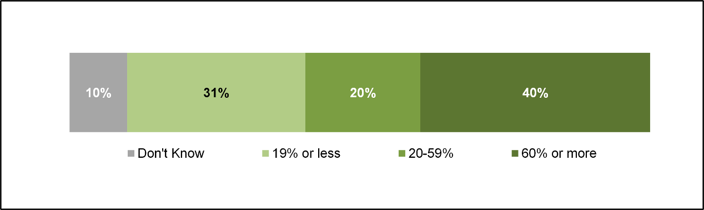
B6: What proportion of the total invested in plant and machinery eligible for CA was spent on second hand assets? Base: Invested in Second hand assets (136).

Non-claimant investment behaviour
  - The investment behaviour of non-claimants was similar to that of claimants. All non-claimants involved in the research had invested in assets eligible for capital allowances in 2019 to 2020 and, like claimants the most common types of assets invested in were IT equipment, office equipment and machinery and tools.
  - The primary motivation behind non-claimants making investments were also similar to that of claimants. Non-claimants made investments to maintain and improve productivity. Businesses mentioned that they invested in assets to replace old ones that were at the end of their life. Others invested in assets that were an upgrade from previously used ones, or to allow employees to work from home which they found increased productivity. Finally, some non-claimants invested in assets as part of a growth strategy, such as to grow their capacity to hire more people.
“We don't really have huge one-off items. We're often just replenishing what we've got and keeping up to date.”
Non-claimant, Finance and Insurance, Large
“There were additional employees taken on so a need for more computer equipment. We try to improve computer equipment as clients visit us so we need to be seen to have all the pieces of tech.”
Non-claimant, Professional, Scientific and Technical, Micro
“We purchased a small lathe and welder to make components that have been traditionally sourced elsewhere. Simple things that were costing us a fortune to buy in and were easy to make ourselves.”
Non-claimant, Manufacturing, Micro

  - Like claimants, non-claimants tended to purchase assets new rather than second-hand. The interviewees mostly highlighted cost-related reasons for choosing second-hand assets. Tax and capital allowances often had no influence over decisions to purchase the equipment. Non-claimants typically funded their investments through funds held by the businesses. Only one non-claimant spoken to had borrowed funds.

Use of capital allowances

  - This chapter begins by addressing the types of capital allowances claimed in the 2019 to 2020 tax year and the factors motivating their use. The chapter then moves on to explore the proportion of businesses that claimed the Super-Deduction in 2020 to 2021 or intended to claim it in 2022 to 2023. Finally, the reasons for non-use of capital allowances are considered.

Types of capital allowances claimed
  - As covered in Chapter 3, all claimant businesses surveyed were aware that they had claimed a capital allowance in 2019 to 2020. However, this did not always translate to an awareness of the type of capital allowance claimed. Just over half (52%) were aware of which capital allowance(s) they had claimed in the 2019 to 2020 tax year; whilst 48% were unaware, being unable to recall the name of the capital allowance claimed. Over half (53%) of incorporated claimant businesses and two-fifths (39%) of unincorporated claimant businesses were aware of which allowance(s) they had claimed.
  - Figure 5.1 presents which specific capital allowances businesses recalled claiming in the 2019 to 2020 tax year: most commonly the Annual Investment Allowance (AIA), by 29% of claimant businesses, followed by the main rate of Writing Down Allowances (WDAs) (19%) and Research and Development Allowances (RDAs) (12%). Fewer than 10% of claimant businesses claimed each of the other types of capital allowances.
Figure 5.1 Types of capital allowances claimed in 2019 to 2020 tax year
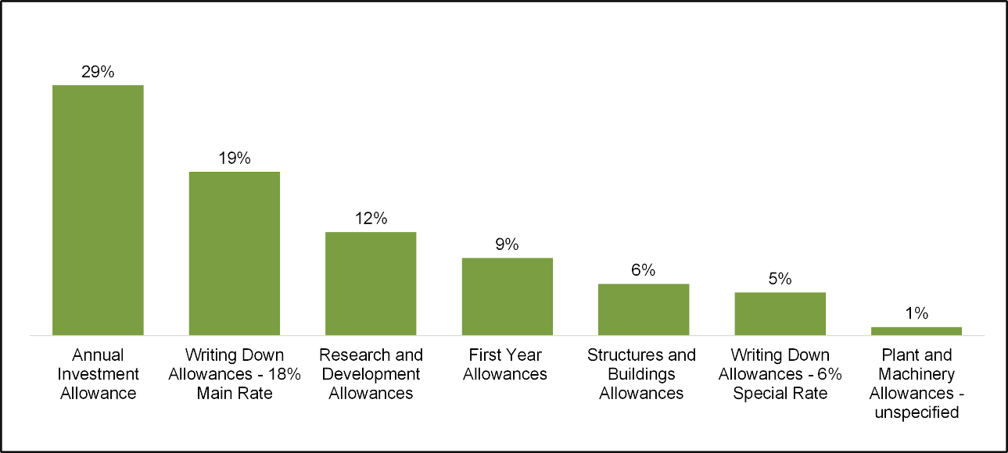
C1: What Capital Allowances did your business claim in the 2019 to 2020 tax year. Base: All claimants (940)
  - For incorporated businesses, the top three most commonly claimed capital allowances were AIA (30%), main rate of WDAs (20%) and RDAs (13%). For unincorporated businesses the top three capital allowances claimed were: AIA (18%), main rate of WDAs (13%) and the Structures and Buildings Allowance (SBA) (11%).
  - Among incorporated businesses, larger businesses were more likely to claim most capital allowances than smaller businesses. For example, micro businesses were less likely than average to have claimed AIA (26%), whereas medium and large businesses were more likely than average (52% and 54% respectively). Furthermore, 12% of micro businesses claimed WDAs main rate, rising to 28% of small businesses, 53% of medium businesses, and 68% of large businesses.
  - Amongst incorporated businesses, there were some significant patterns as to which capital allowances were claimed by the types of assets invested in:
  - AIA was more likely to be claimed by business that invested in IT equipment (33%)
  - the main rate of WDAs was more likely to be claimed by businesses that invested in cars (39%), construction plant (37%), building fixtures and fittings (29%), vans and lorries (29%) or machinery and tools (27%)
  - RDAs were more likely to be claimed by businesses that invested in construction plant (34%)
  - FYAs were more likely to be claimed by businesses that invested in cars (18%) or vans/lorries (17%).
  - With regards to sector, incorporated businesses operating in the financial and insurance activities and professional scientific and technical activities sectors were more likely to have claimed the AIA (54% and 47% respectively). Those in the financial and insurance activities sector were also more likely to have claimed main rate WDAs (34%). Businesses in manufacturing (30%) and construction, water supply, mining and quarrying (22%) were more likely to have claimed RDAs.

Decision making process behind claims
  - Qualitative interviews found that most claimant businesses were not directly involved in the decision to claim capital allowances in 2019 to 2020. Instead, it was their tax agent or accountant who identified eligible investments and the most appropriate capital allowance. The decision to outsource capital allowances claims was typically based upon a lack of time or expertise, or a mixture of the two.
  - Although usually not directly involved in selecting specific capital allowances, this is not to say that claimant businesses were totally detached from the decision to claim capital allowances in general. They knew that capital allowances were available and wanted to claim them to reduce their tax bill and maintain cash flow, but they tended to outsource the identification of relevant capital allowances and the associated administrative work to third parties. This goes some way to explaining why many businesses surveyed were unaware of the name of the capital allowance they claimed.
“I couldn’t tell you which specific capital allowances were claimed. I pass everything on to my accountant. We have too much to do on a day-to-day basis, that’s why we pay someone.”
Claimant, Construction, Medium
“My accountant would say you've spent X on this project, and these are the allowances you can claim … I would take the advice from him. If he said it was applicable or allowable, then we would claim it. This area of the business I would 100% defer to him.”
Claimant, Accommodation and Food, Small
“Our auditors or accountant prepare all our tax computations and tell us what we can claim. The thought process is to claim as much as we can upfront to get the biggest tax benefit in the year we made the expenditure.”
Claimant, Transportation and Storage, Medium
  - Some businesses were actively involved in the decision-making process around which specific capital allowance were relevant and best suited to their investments. These decisions were often based upon which capital allowances offered the highest rate of relief and the time it takes for that relief to be realised. For example, several explained how they preferred to use AIA on new investments, rather than WDA, as there was 100% relief in the same tax year.
“Because we are a manufacturing business, when we have lots of capital expenditure to get this back as part of Writing Down Allowance over twenty odd years is a bit of a pain. So, we would always choose to get the AIA if we can; but there are things where you can’t, so that goes in the pool and we let the auditors claim the maximum they can legally.”
Claimant, Manufacturing, Medium
“AIA was claimed on items we could write off 100% in the first year, regards to writing down, that's the pool the vehicles and air conditioning units, we would have claimed the correct allowances depending on how they were brought forward from the previous period. R&D was claimed in that period after a big change in one of our systems ... this came about through business needs ... not looking to claim a tax benefit; [it was client request to update a process for them].”
Claimant, Construction, Medium
“The net profit we're making is equalised by the Capital Allowances. From a cashflow perspective it would have helped us…We've got lots of cash at the moment, but if we hadn't had capital allowances for the last twenty years we probably wouldn't have”
Claimant, Wholesale and Retail, Large

Super-Deduction claims
  - The Super-Deduction was introduced in April 2021 and was available for two years. It was therefore not available in the 2019 to 2020 tax year which the survey of claimants focused on. However, the survey (conducted between July and September 2022) did offer the opportunity to explore whether businesses had claimed, or planned to claim, this capital allowance between April 2021 and April 2023.
  - Almost half (46%) of claimant businesses aware of the Super-Deduction had claimed it (10%) or planned to claim it (36%) on investments made in the 2021 to 2022 tax year. Among these businesses, the mean value of investments that qualified for the Super-Deduction in 2021 to 2022 was £184,865 and the median value was £25,000. The full distribution is shown in Figure 5.2.

Figure 5.2 Value of investments that qualified for Super-Deduction in 2021 to 2021 to 2022 tax year
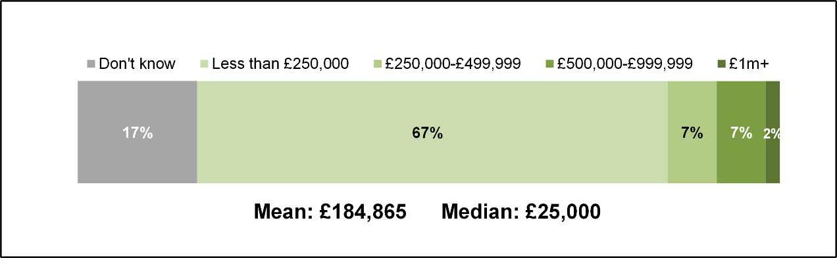
F7: What was the total value of your investments that qualified for Super-Deduction capital allowance in the 2021 to 2022 tax year. Base: All who have claimed or plan to claim Super-Deduction capital allowance in 2021 to 2022 tax year (170)
  - Among incorporated businesses, small businesses (59%), those that invested in construction plant (77%) or vans and lorries (68%) and those investing over £100,000 in eligible assets were more likely to have claimed or intend to claim the Super-Deduction in 2021 to 2022.
  - Around two-fifths (42%) of claimant businesses aware of the Super-Deduction intended to claim it on investments planned for 2022 to 2023 tax year. Among these businesses, the mean value of investments expected to qualify for the Super-Deduction in 2022 to 2023 was £1,036,680 and the median value was £3,000. The full distribution is shown in Figure 5.3.
Figure 5.3 Expected value of investments that will qualify for Super-Deduction in 2022 to 2023 tax year
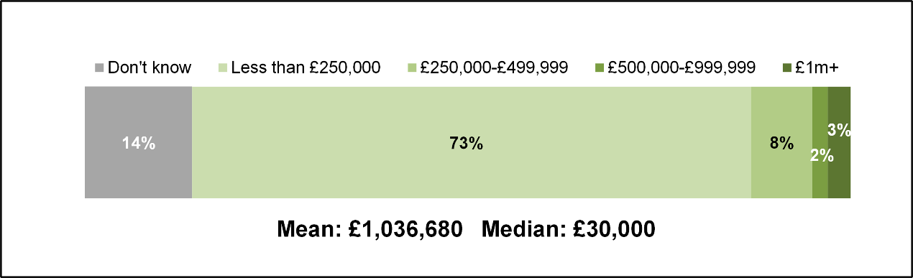
F17: What do you expect to be the total value of your investments that qualify for the Super-Deduction capital allowance in the 2022 to 2023 tax year. Base: All who plan to claim Super-Deduction capital allowance in 2022 to 2023 tax year (172)
  - Among incorporated businesses, medium (61%) and large businesses (63%), those that invested in construction plant (70%), building fixtures and fittings (55%) or office equipment (53%) were more likely to intend to claim the Super-Deduction in 2022 to 2023.

Non-use of capital allowances

Claimants: Super-Deduction
  - Claimant businesses that were aware of the Super-Deduction but did not claim or plan to claim it typically attributed this to no investments being planned in the timeframe the capital is available (before March 2023). Others did make investments in 2021 to 2022 or intended to in 2022 to 2023, but these investments were in asset types that did not qualify for the Super-Deduction. For example, some had purchased or intended to purchase second-hand equipment or invest in buildings and structures.
“We didn’t have any major CapEx that was relevant to it. As straightforward as that because we are a largely property dominated group, you don’t just go out and buy a large building just because you can get the tax relief.”
Claimant, Health and Social Work, Large
  - Another reason for not claiming the Super-Deduction was that businesses were given advice from tax agents and accountants to claim alternative capital allowances. These businesses were often unable to comment on rationale for this but followed the recommendations of their agent or accountant because they trusted them.

Claimants: Structures and Buildings Allowance
  - Amongst claimant businesses that invested in buildings and structures but did not claim the SBA in 2019 to 2020, many were unaware that this capital allowance existed. Some mentioned that they were reliant on the advice of tax agents or accountants, who had not informed them of this capital allowance being available.
  - Amongst those aware of the SBA, some had not claimed it because the nature of their investment did not meet the eligibility criteria. For example, one business owner had invested in the construction of a premises at their home address, which did not qualify for the SBA. Some said they had claimed alternative capital allowances because they had identified them as more appropriate or because their tax agent or accountant had advised them to.

Non-claimants
  - The three main reasons non-claimants did not claim capital allowances in 2019 to 2020 were small scale investments, limited awareness or understanding of capital allowances and loss-making.
  - Some non-claimants did not claim capital allowances because their business only had a small investment expenditure in 2019 to 2020. These non-claimants felt that claiming capital allowances would not have made a difference when only small amounts are invested, and the claims they would receive was not worth the administrative burden of the claims process. However, some would have considered making a claim if their investment amount had been higher.
"It would probably not be worth the time and effort."
Non claimant, Information and Communication, Small
“[Capital allowances] have never seemed to be an important thing for me to spend my time on … I don't think they’re going to be worth much to us, because we haven't spent much.”
Non-claimant, Manufacturing, Micro

  - Limited understanding and awareness of capital allowances contributed to non-use amongst many non-claimants. Some did not know that capital allowances were available and those that were aware of their availability often did not have a good understanding of how they worked and which assets were eligible. A few attributed non-use to their tax agent or accountant not recommending capital allowances as an option.
"There was no communication or recommendation from our tax experts about claiming it."
Non-claimant, Wholesale and Retail Trade, Medium
  - A few businesses did not claim capital allowances in 2019 to 2020 because they were loss making in that tax year. These non-claimants had considered claiming capital allowances on eligible investments but felt that there were no benefits of doing so if the business was not making a profit.
"We'd made considerable trading losses in that period, so we did not need to claim allowances to shelter our tax liability."
Non-claimant, Finance and Insurance, Large
"If the business does not make a profit there is no benefit to claiming them."
Non claimant, Information and Communication, Small
  - A few non-claimants had considered claiming capital allowances on investments made in 2019 to 2020 but decided against it for reasons other than those listed above. For example, one business said they were waiting until the rate of Corporation Tax “settled” while another decided against claiming capital allowances because of perceived administrative burden.
“It was considered but at the time information available made it seem odd to claim when CT rates were going to be changing.”
Non-claimant, Professional, Scientific and Technical, Medium
  - Although no non-claimant businesses claimed capital allowances in 2019 to 2020, some had claimed them in other tax years. For example, one business claimed the AIA on an investment in IT equipment in 2016 to 2017, whilst another claimed Super-Deduction for laboratory equipment in 2021 to 2022. The motivations behind making these claims were similar to those mentioned by claimants, namely because they presented a means to reduce their tax bill and improve cashflow. Tax agents and accountants were heavily involved in the decision-making process.
“It is a very straightforward exercise to claim it, and it feels good when you see your corporation tax has reduced.”
Non-claimant, Financial and Insurance, Micro
  - Some non-claimants said they would consider claiming capital allowances in the future. For some, this was borne out of their involvement in this research improving their awareness and understanding. Others had intentions to claim capital allowances already but were waiting for the right moment (for example, when they become profit-making).
“I certainly plan to claim the super deduction before the end of March especially as you are getting the 130%.”
Non-claimant, Professional Scientific and Technical, Micro
“We will claim capital allowances when the company starts making a profit, so we can increase the taxable profit.”
Non-claimant, Accommodation and Food, Large

The influence of the capital allowances on investment behaviour

  - This chapter explores the extent to which the capital allowances claimed in the 2019 to 2020 tax year shaped the investment behaviour of claimant businesses. The chapter begins by addressing the influence of capital allowances in general, both in terms of incentivising investment and influencing the value and timing of investments. The chapter then moves on to focus specifically on the influence of Structures and Buildings Allowance (SBA) and the Super-Deduction capital allowance, before looking at the potential effect of hypothetical changes to capital allowances.

Extent to which capital allowances influence investment
  - As presented in Table 6.1, nearing three-fifths (57%) of businesses agreed that capital allowances incentivise them to make investments in assets and around half agreed that capital allowances enable them to make more frequent investments and larger financial investments than they would otherwise (both 52%).
Table 6.1 Extent to which capital allowances incentivise investment, enable more frequent investments and enable larger financial investments
- | Don't know | Strongly disagree | Disagree | Neither / nor | Agree | Strongly agree | NET AGREE
Capital allowances incentivise the business to invest in equipment | 3% | 1% | 12% | 27% | 43% | 14% | 57%
Capital allowances enable the business to invest in equipment more often | 4% | 2% | 16% | 26% | 39% | 13% | 52%
Capital allowances enable the business to make larger financial investments | 3% | 2% | 17% | 25% | 40% | 12% | 52%
G2: To what extent do you agree or disagree with the following statements: _1 Capital allowances incentivises your business to invest in equipment; _3 Capital allowances enables your business to invest in equipment more often _4 Capital allowances enable your business to make larger financial investment in equipment. Base: All claimants (940)
  - Focusing in on the first statement presented in Table 6.1, 58% of incorporated businesses and 54% of unincorporated businesses agreed that capital allowances incentivise investment in equipment. In both groups around one in seven strongly agreed (15% incorporated and 14% unincorporated). Amongst incorporated businesses, those that invested between £25,000 and £99,999 and those that invested in cars (72%) or IT equipment (62%) were more likely to agree. Large incorporated businesses (45%) were less likely to agree, as shown in Table 6.2 below where a full breakdown by size for incorporated businesses is presented.

Table 6.2 Agreement with statements regarding the impact of capital allowances, incorporated businesses
- | Micro | Small | Medium | Large | All
AGREE: Capital allowances incentivise your business to invest in equipment | 57% | 60% | 59% | 45%** | 58%
DISAGREE: Capital allowances incentivise your business to invest in equipment | 13% | 14% | 10% | 23%* | 13%
AGREE: Capital allowances enable your business to invest in equipment more often than you would otherwise | 54% | 46% | 51% | 41%** | 52%
DISAGREE: Capital allowances enable your business to invest in equipment more often than you would otherwise | 16%** | 26%* | 17% | 33%* | 19%
AGREE: Capital allowances enable your business to make larger financial investment in equipment than you would otherwise | 55%* | 44%** | 52% | 47% | 52%
DISAGREE: Capital allowances enable your business to make larger financial investment in equipment than you would otherwise | 17%** | 30%* | 20% | 28% | 21%
G2: To what extent do you agree or disagree with the following statements: _1 Capital allowances incentivises your business to invest in equipment; _3 Capital allowances enables your business to invest in equipment more often _4 Capital allowances enable your business to make larger financial investment in equipment. Base: All incorporated businesses (833), Micro (312), Small (179), Medium (217), Large (125). ** denotes significantly lower than the average, * denotes significantly higher than the average.
  - With regards to capital allowances enabling businesses to make investments more often than they would otherwise, 52% of incorporated businesses and 55% of unincorporated businesses agreed. A similar proportion of both groups strongly agreed (13% incorporated and 15% unincorporated). Amongst incorporated businesses, those who invested in cars (65%), IT software (60%) or office equipment (58%) were more likely to agree. Large businesses (41%) were less likely than average to agree.
  - With regards to capital allowances enabling businesses to make larger financial investments than they would otherwise, 52% of incorporated businesses and 54% of unincorporated businesses agreed. Amongst both groups, around one in eight strongly agreed (12% respectively). Amongst incorporated businesses, micro businesses (55%), those that invested in cars (68%), IT software (62%) or office equipment (58%) were more likely to agree.
  - Although the quantitative survey found that most businesses agreed that capital allowances incentivise them to make investments and that capital allowances enable them to make more frequent and larger financial investments, the qualitative interviews indicated that the degree of influence capital allowances have on business investment behaviour was more nuanced.
  - Most businesses said they invested in assets because of potential gains to the business (e.g., improved productivity and growth) or because of an essential need for new assets (e.g., replacing broken equipment). Therefore, capital allowances were not typically a consideration in their decision-making process around investments. Only in a handful of cases did businesses say that capital allowances had a strong bearing over the decision to invest in assets. This was typically because they were seen to offer businesses a means to ‘reduce tax bills’ and ‘offset tax’.
“It is a nice thing to know that you can get [capital allowances] on the expenditure, but it is not a key driver in terms of making the expenditure. It is more to do with what we need in the business and what needs replacing.”
Claimant, Transportation and Storage, Medium
“We spend what we need to spend and it's nice to know that the taxman is going to contribute something to it… but if there were no tax allowances, we'd still have to spend the money.”
Claimant, Professional, Scientific and Technical, Micro
  - Although capital allowances were rarely identified as an incentivising factor behind investments, some businesses said they shaped the timing and value of investment. For these businesses, the design of capital allowances encouraged them to make planned investments before the end of the tax year and, in a few cases, pushed them to invest in higher value equipment than they would otherwise.
“A capital allowance makes it cheaper to buy things, so yes you buy more expensive and better-quality kit.”
Claimant, Manufacturing, Micro
“If there was a good allowance and that was going to disappear, we probably would look at the timing of our investments rather than leaving something for a year or so. We would move some investment decisions forward if it is something we are going to have to do anyway.”
Claimant, Transportation and Storage, Medium

Influence of the Structures and Buildings Allowance
  - The Structures and Buildings Allowance (SBA) is a capital allowance introduced in October 2018 that can be claimed on the construction of new commercial buildings and structures and the renovation or conversion of existing commercial buildings and structures. In April 2020 the rate of relief available on the SBA increased from 2% to 3%.
  - As presented in Figure 6.1, amongst those that had invested in buildings and structures since the 2017 to 2018 tax year, the introduction of this capital allowance and the subsequent increase in the rate of relief had no impact on the amount most businesses had invested in these assets. With regards to its introduction, two-thirds (65%) said their investment stayed the same while only around one in seven (15%) increased their investment. With regards to the increase in the rate of relief, more than three-quarters (77%) said their investment stayed the same while only around one in fourteen (7%) increased their investment.
Figure 6.1 Impact of the introduction of SBA and the change in the rate of SBA on amount invested in buildings and structures
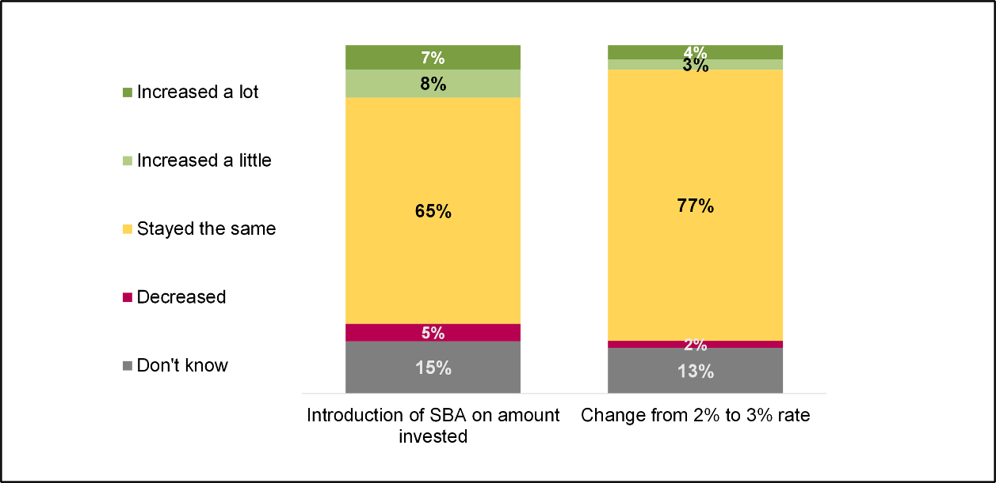
B7: Did the introduction of the structures and building allowances in October 2018 affect the amount your business invested in buildings and structures? B8: Did the increase of the structures and building allowances rate from 2% to 3% in April 2020 affect the amount your businesses invested in buildings and structures? Base: Invested in buildings and structures after 17/18 (123)
  - There were no statistically significant differences in the survey data to indicate the types of businesses who were more likely to have increased the value of investment buildings and structures in response to the introduction of the SBA or the increase in the rate of relief.
  - However, findings from follow-up interviews pointed towards it being businesses that made larger financial investments in buildings and structures that were influenced most by the SBA. For these businesses, the rate of relief available made a considerable difference to their taxable profits at the end of the tax year. One business estimated that in the 2019 to 2020 tax year claiming the SBA reduced their exposure to corporation tax by £2 million.
“If you do get even a small contribution towards [buildings and structures], which you effectively do with the SBA, it does tip quite a few of those decisions.”
Claimant, Transportation and Storage, Large

Influence of the Super-Deduction
  - As noted in Chapter 5, the Super-Deduction was introduced in April 2021, and was therefore not available in the 2019 to 2020 tax year which the survey of claimants focused on. However, the survey did offer the opportunity to explore the influence of the capital allowance on the investment behaviour of businesses in later tax years. Specifically, the influence it had on the timing and value of investments made in 2021 to 2022 and investments planned for 2022 to 2023.
  - Focusing on investments made in the 2021 to 2022 tax year, around one in five (19%) of the businesses that had claimed or planned to claim the Super-Deduction in 2021 to 2022 said that its introduction had shaped the timing and value of investments. As detailed in Figure 6.2, 12% brought forward investments into 2021 to 2022, 9% made investments that were unplanned before the introduction of the Super-Deduction and 6% invested a higher amount because of the introduction of the Super-Deduction. There were no significant differences by business size. Table 6.3 presents a breakdown of responses by size for incorporated businesses.
Figure 6.2 Impact of the introduction of the Super-Deduction on investment behaviour in 2021 to 2022
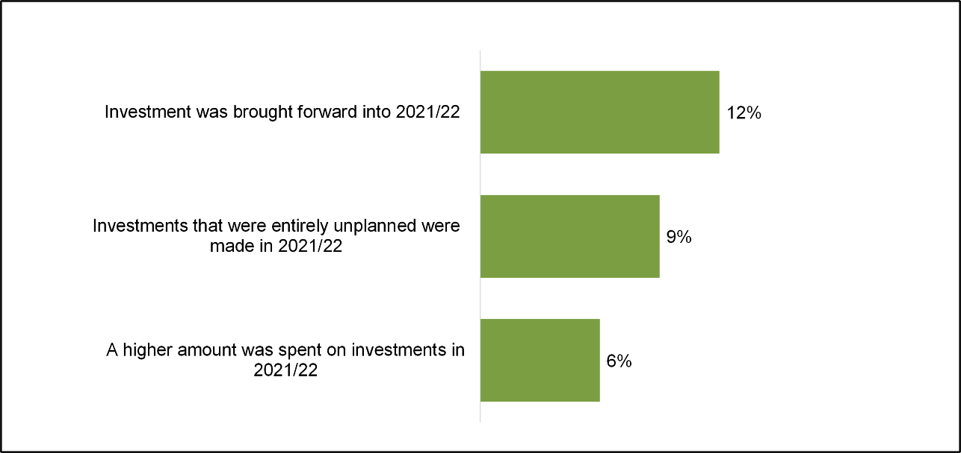
F9: Effects the introduction of Super-Deduction had on investment decisions in the 2021 to 2022 tax year? Base: All who have claimed or plan to claim Super-Deduction in 2021 to 2022 (170). NB: Businesses could select more than one effect. Therefore, the percentages do not sum to 19%.
Table 6.3 Potential effects of the introduction of Super-deduction in 2021 to 2022 by business size, incorporated businesses
- | Micro | Small | Medium | Large | All
Investment were brought forward into 2021 to 2022 because of the introduction of the super-deduction | 58% | 55% | 87% | 77% | 64%
Investments that were entirely unplanned were made in 2021 to 2022 because of the super-deduction | 71% | 45% | 11% | 12% | 45%
The introduction of the super-deduction capital allowance led to a higher amount being spent | 63% | 11% | 29% | 21% | 33%
F9: Effects the introduction of Super deduction had on investment decisions in the 2021 to 2022 tax year? Base: All incorporated businesses who have claimed or plan to claim Super deduction in 21 to 2022 (39), Micro (5), Small (8), Medium (20), Large (6).
  - Amongst those that were motivated to bring investments forward into 2021 to 2022, most businesses had originally planned to make these investments in the following tax year (2022 to 2022 to 2023) and had brought forward a small proportion of the value of investments (typically less than a quarter). A handful of businesses had brought investment plans forward by more than a year and a few had brought forward 100% of the value of investments that qualified for the Super-Deduction. When the percentage of spend brought forward was applied to the total value of investments that qualified for the Super-Deduction, the mean value of investment brought forward was £74,100 and the median was £28,400. As a percentage of the total value of investments that qualified for the Super-Deduction, the average increase in investments brought forward into 2021 to 2022 was 23%.
“We used [Super-Deduction] as justification in the process of investing in a new business system. We've managed to bring that one forward on the basis of an extra 30% allowance potentially available to us”
Claimant, Agriculture, Forestry and Fishing, Medium
  - Amongst those that made investments that were previously unplanned, most reported that less than half of the total value of investments that qualified for the Super-Deduction made in 2021 to 2022 happened because of the introduction of the Super-Deduction. A couple of businesses said 100% of the value of investments made happened because of the capital allowance being introduced. When the percentage of unplanned spend was applied to the total value of investments that qualified for the Super-Deduction, the mean value of unplanned investment was £208,900 and the median was £87,800. As a percentage of the total value of investments that qualified for the Super-Deduction, the average increase in investments that were previously unplanned was 55%.
“The extra 30% on Super-Deduction caused the business to bulk buy laptops in 2021 to 2022… we knew an extra 30% of relief was available so we bought more laptops. In that year we bought 5. We may have only bought 3 otherwise.”
Claimant, Professional, Scientific and Technical Services, Small
  - Amongst those that invested a higher amount in assets that qualified for the Super-Deduction, most reported that between 1% and 20% of the value of investments was additional spend that occurred as a result of the capital allowance being introduced. When the percentage of additional spend was applied to the total value of investments that qualified for the Super-Deduction the mean uplift in investment was £156,000 and the median was £57,000. As a percentage of the total value of investments that qualified for the Super-Deduction, the average increase in investments that was additional spend was 33%.
“We put an extra £100,000 into that machinery because of [the Super-Deduction], from £150,000 to £250,000. This is because we realised we were getting a huge win from a tax perspective.”
Claimant, Manufacturing, Medium
  - With regards to the 2022 to 2023 tax year, around one in three (29%) of the businesses that planned to claim the Super-Deduction in 2022 to 2023 said that its introduction had shaped the timing and value of planned investments. As detailed in Figure 6.3, 26% of these businesses intended to bring forward investments into 2022 to 2023, 11% planned to invest a higher amount than originally planned because of the introduction of the Super-Deduction and 6% planned to make investments that were unplanned before the introduction of the Super-Deduction. As presented in Table 6.4, there were no significant differences by size amongst incorporated businesses.
Figure 6.3 Impact of the introduction of the Super-Deduction on planned investment behaviour in 2022 to 2023
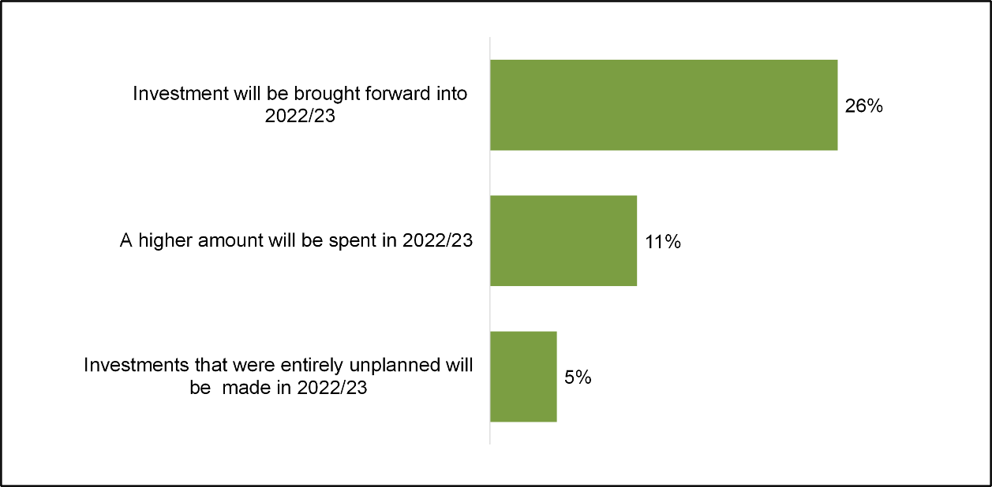
F19: Potential effects the introduction of Super-Deduction had on investment decisions in the 2022 to 2023 tax year? Base: All who plan to claim SD in 2022 to 2023 tax year (172). NB: Businesses could select more than one effect. Therefore, the percentages do not sum to 29%.
Table 6.4 Potential effects the introduction of Super Deduction had on investment decisions in the 2022 to 2023 financial year, incorporated businesses
- | Micro | Small | Medium | Large | All
Investments will be brought forward into 2022 to 2023 because of the introduction of the super-deduction | 86% | 92% | 91% | 86% | 89%
The introduction of the super-deduction capital allowance will lead to a higher amount being spent | 28% | 52% | 30% | 28% | 38%
Investments that were entirely unplanned are being made in 2022-23 because of the super-deduction | 14% | 25% | 5% | 21% | 17%
F19: Potential effects the introduction of Super-Deduction had on investment decisions in the 2022 to 2023 tax year? Base: All incorporated businesses who plan to claim SD in 2022 to 2023 tax year (54), Micro (7), Small (9), Medium (30), Large (8).
  - The specific ways in which the Super-Deduction influenced investment plans for 2022 to 2023 were very similar to the ways in which the introduction of the capital allowance influenced behaviour in 2021 to 2022.
  - Amongst those that planned to bring investments forward, most had originally planned to make these investments in the following tax year (2023 to 2024) and had brought forward a small proportion of the value of investments (typically less than half). Amongst those that intended to spend a higher amount on assets that qualified for the Super-Deduction, many reported that between 21% and 50% of the value of investments would be additional spend. Amongst those that intended to make investments that were previously unplanned, most reported that less than half of the total value of investments planned for 2022 to 2023 that will happen because of the introduction of the Super-Deduction.
“Because it's due to be phased out in April 2023, where we have got expenditure that's falling in April, May, June next year, if we can bring that forward to capture the Super-Deduction early, we might look to see if we can drag forward a bit of that CapEx.”
Claimant, Health and Social Work, Large
“Longer term investment plans have been brought forward, and this will possibly have a knock-on effect so that all investments are brought forward in line. This will in effect increase the total investment over a longer period.”
Claimant, Administrative and Support Services, Large

Influence of hypothetical scenarios
  - Claimant businesses were presented with five hypothetical scenarios about capital allowances and asked to what extent, if at all, these scenarios would have an influence on their investment spend. These were:
- The permanent level of the Annual Investment Allowance (AIA) being increased to £500,000
- The Writing Down Allowances (WDAs) for main rate assets being increased from 18% to 20% and for special rate assets from 6% to 8%
- A First Year Allowance (FYA) being introduced for main and special rate assets where businesses can deduct 40% for main rate assets and 13% for special rate assets in the first year
- An additional FYA being introduced to bring the overall amount that can be claimed to greater than 100% of the initial cost
- Full expensing being introduced to allow businesses to write off the costs of qualifying investment in one go
  - As shown in Table 6.5, none of these hypothetical scenarios would result in the majority of claimant businesses increasing their investment spend. The two most impactful scenarios were full expensing being introduced to allow businesses to write off the costs of qualifying investment in one go (scenario E) and an additional FYA being introduced to bring the overall amount that can be claimed to greater than 100% of the initial cost (scenario D).
  - Around a third (36%) of businesses (37% incorporated and 28% unincorporated businesses) said that full expensing being introduced to allow businesses to write off the costs of qualifying investment in one go (scenario E) would result in increased investment. Amongst incorporated businesses, medium sized businesses (50%), those that invested in cars (62%), building fixtures and fittings (47%) or office equipment (43%) were more likely to say that this scenario would cause an increase in investment. Table 6.6 presents a breakdown of responses by size for incorporated businesses.
  - Around a third (35%) of businesses (36% incorporated and 27% unincorporated businesses) said an additional FYA being introduced to bring the overall amount that can be claimed to greater than 100% of the initial cost (scenario D) would result in increased investment. Like with the introduction of full expensing amongst incorporated businesses, medium sized businesses (51%), those that invested in cars (49%), building fixtures and fittings (46%) or office equipment (43%) were more likely to say that this scenario would cause an increase in investment. Table 6.6 presents a breakdown of responses by size for incorporated businesses.
Table 6.5 Impact of hypothetical capital allowance scenarios on investment behaviour
- | Don’t know | Decrease | Stay the same | Increase a little | Increase a lot | NET INCREASE
E. Full expensing being introduced to allow businesses to write off the costs of qualifying investment in one go | 21% | 2% | 41% | 23% | 14% | 36%
D. An additional FYA being introduced to bring the overall amount that can be claimed to greater than 100% of the initial cost | 22% | 1% | 42% | 21% | 14% | 35%
C. A FYA being introduced for main and special rate assets where businesses can deduct 40% for main rate assets and 13% for special rate assets in the first year | 22% | 1% | 55% | 16% | 6% | 23%
B. The WDAs for main rate assets is increased from 18% to 20% and for special rate assets from 6% to 8% | 21% | 1% | 58% | 19% | 2% | 21%
A. The permanent level of the AIA is increased to £500,000 | 17% | 1% | 64% | 10% | 7% | 17%
G1_1-5: What impact would these hypothetical scenarios have on your business investment? Base: All claimants (940)

Table 6.6 Net agreement with impacts of hypothetical scenarios on business investment by size, incorporated businesses
- | Micro | Small | Medium | Large | All
E. Full expensing being introduced to allow businesses to write off the costs of qualifying investment in one go | 35% | 42% | 50%* | 42% | 37%
D. An additional FYA being introduced to bring the overall amount that can be claimed to greater than 100% of the initial cost | 33%** | 41% | 51%* | 43% | 36%
C. A FYA being introduced for main and special rate assets where businesses can deduct 40% for main rate assets and 13% for special rate assets in the first year | 20% | 26% | 33%* | 31% | 22%
B. The WDAs for main rate assets is increased from 18% to 20% and for special rate assets from 6% to 8% | 19% | 25% | 22% | 23% | 21%
A. The permanent level of the AIA is increased to £500,000 | 16% | 16% | 24% | 18% | 17%
G1_1-5: What impact would these hypothetical scenarios have on your business investment? Base: All incorporated businesses (833), Micro (312), Small (179), Medium (217), Large (125). ** denotes significantly lower than the average, * denotes significantly higher than the average.
  - During qualitative interviews, businesses that felt these two scenarios would result in increased investment spend typically attributed this to an expectation that these scenarios would help improve cashflow and allow them to ‘see’ the relief sooner than existing capital allowances. This was particularly pronounced for an additional FYA being introduced. It was explained that a rate of relief greater than 100% would enable them to retain more profits, which in turn would free up more funds for investment. Some likened this scenario to the Super-Deduction capital allowance.
“If you were getting a deduction in year one for the expenditure, your profitability is higher.”
Claimant, Administrative and Support Services, Large
“If you could claim back more than you paid, it would be stupid not to claim it, and probably invest more but only if necessary.”
Claimant, Information and Communication, Micro
  - Those that said their investment would stay the same under these scenarios tended to attribute this to their investment behaviour being driven by business need rather than the availability of capital allowances. With regards to the introduction of full expensing, some said that their investment would stay the same if full expensing was introduced because this scenario would not drastically change the capital allowance landscape for their business.
“We wouldn’t be letting the tax dog wag the commercial tail. We would invest in something because it is needed to run the business and not because we can get extra tax relief.”
Claimant, Health and Social Work, Large
“It wouldn't move the goalposts… this scenario matches what already exists under AIA.”
Claimant, Professional, Scientific and Technical, Small
  - For the other three hypothetical scenarios, most businesses said their investment would stay the same under these circumstances. The least impactful was the permanent level of AIA at £500,000 (scenario A), with around two-thirds (64%) saying that their investment spend would stay the same and fewer that one in five (17%) saying this would result in increased spend.

Disposals and depreciation

  - This chapter starts by covering the disposal of assets in 2019 to 2020, including the types of assets disposed, their value and the means of disposal. Following on from this, the chapter covers whether the depreciation rates used by the business differ from the rates of Writing Down Allowances and, if so, the extent to which they differ.

Disposals
  - A fifth (20%) of claimant businesses disposed of assets in 2019 to 2020. This ranged from 21% amongst incorporated businesses to 10% amongst unincorporated businesses.
  - Focusing on incorporated businesses, medium (45%) and large (48%) businesses were more likely to have disposed of assets, compared to 14% of micro businesses and 29% of small businesses. Businesses who invested in construction (45%), cars (44%) and vans and lorries (44%) were most likely to have disposed of assets.
  - The mean value of assets disposed of in 2019 to 2020 was £104,340 and the median value was £5,000. Figure 7.1 shows the full distribution. For incorporated businesses, the mean value of disposed assets was £106,450 and the median value was £5,000. For unincorporated businesses, the mean value was £67,100 and the median was £10,000.
Figure 7.1 Value of assets disposed of in 2019 to 2020
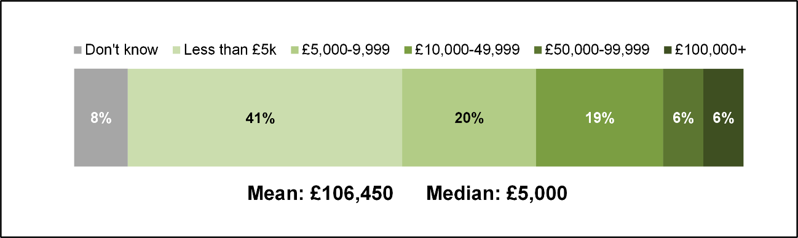
D3: What was the overall value of the assets disposed of in the 2019 to 2020 tax year? Base: All who disposed of assets (276).
  - The value of assets disposed of increased with business size. For example, micro businesses were more likely to dispose of assets worth less than £5,000 (61% vs 42%), while large businesses were more likely to dispose of assets worth over £100,000 (38% vs 5%).
  - The age of disposed assets varied but were usually at least three years old. Figure 7.2 shows that whilst only 8% of businesses that disposed of assets did so after less than one year of use, 37% businesses did so once the assets were more than five years old. The age of disposed assets differed between sectors. For instance, those in the manufacturing sector were more likely to dispose of assets under a year old (23%), while those in the transportation and storage sector were more likely to dispose of assets after 4-5 years of use (39%).
Figure 7.2 Age of assets disposed of in 2019 to 2020
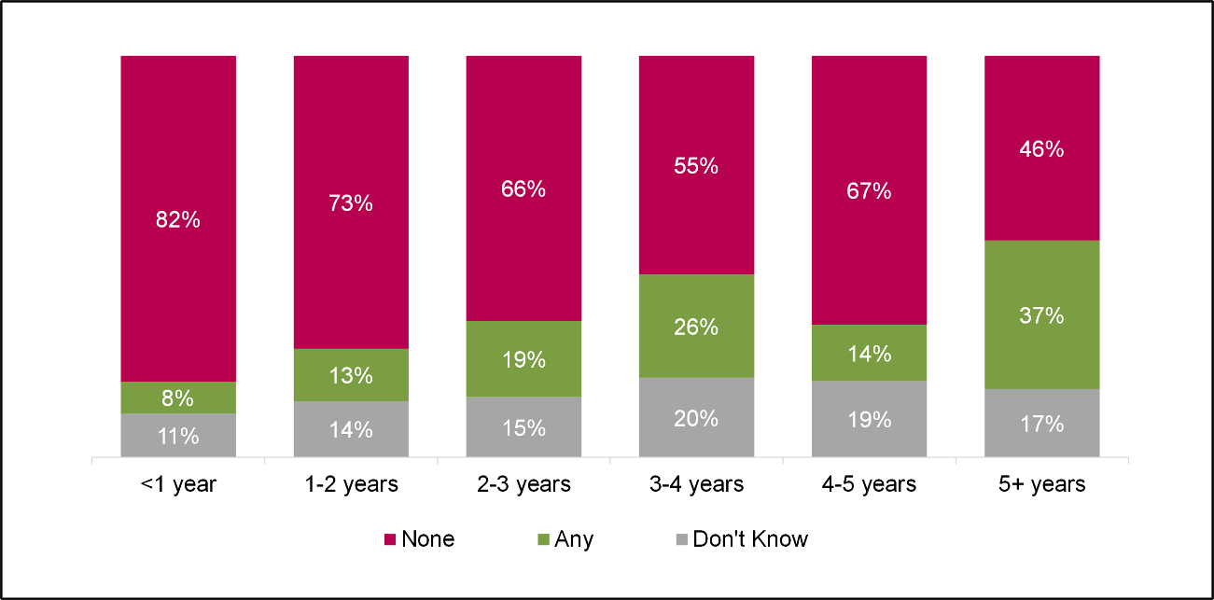
D4: What percentage of your assets disposed of in the 2019 to 2020 tax year were owned for each amount of time? Base: All who disposed of assets (276)
  - As presented in Figure 7.3, two-thirds (66%) of claimants had sold the assets they had disposed of (68% incorporated and 25% unincorporated) and almost half (47%) had had scrapped or destroyed assets (48% incorporated and 27% unincorporated). Around a fifth (18%) used a combination of selling and scrappage (18%). Other methods of disposal used included gifting, recycling, and bartering.
Figure 7.3 Percentage of businesses who used each method of discarding
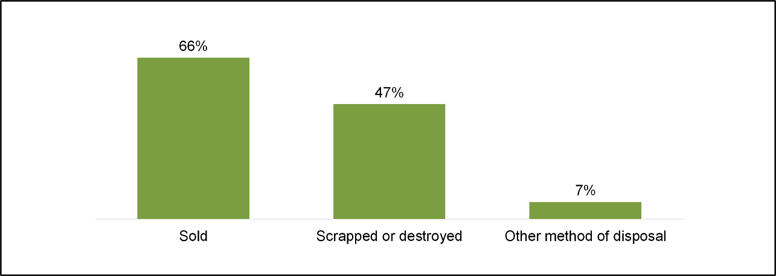D5/D6: What proportion of assets disposed of in the 2019 to 2020 tax year were scrapped or destroyed / sold? D7: Did the business use any other disposal methods other than scrapping and selling to dispose of assets in the 2019 to 2020 tax year? Base: All who disposed of assets (276).

Depreciation
  - Around a quarter (24%) of businesses said there was a difference between the rates of Writing Down Allowances (WDA) and the depreciation rates of their assets (26% incorporated and 12% unincorporated). Medium-sized (59%) and large (80%) businesses, those in the financial and insurance (46%) and professional, scientific and technical activities (42%) sectors were more likely to report a difference between rates of depreciation and of WDAs.
  - Figure 7.4 shows how businesses perceive the value of their assets’ depreciation rates compared to the depreciation rates of WDAs. Of those that claimed the depreciation rate differed from those of WDAs, nearly half (46%) stated that the depreciation rate was higher and while close to a third (31%) stated they were lower.
Figure 7.4 Value of depreciation rates compared to WDA
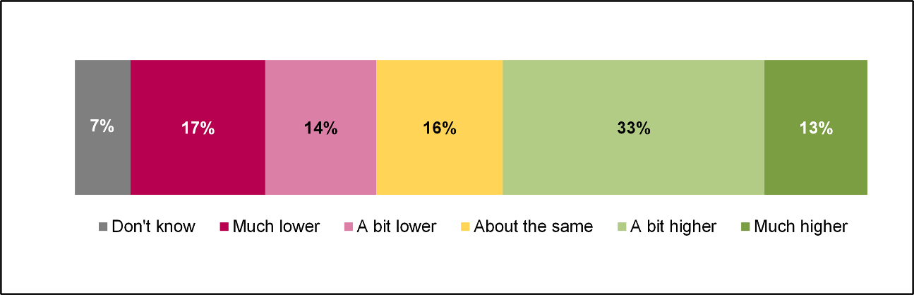
E2: Compared to the Writing Down Allowances, are the depreciation rates used by your business generally…? Base: All aware of differences in depreciation rates (360)

Effects of capital allowances

  - This chapter looks at how capital allowances have affected business growth, and how the government could further support businesses’ use of capital allowances.

Effect of capital allowances on business growth
  - As Figure 8.1 shows, roughly three quarters (74%) of businesses agreed that capital allowances helped with business growth, with 67% of unincorporated and 74% of incorporated businesses agreeing. Around a fifth (17%) neither agreed nor disagreed and 7% disagreed.
Figure 8.1 Agreement that capital allowances help with business growth
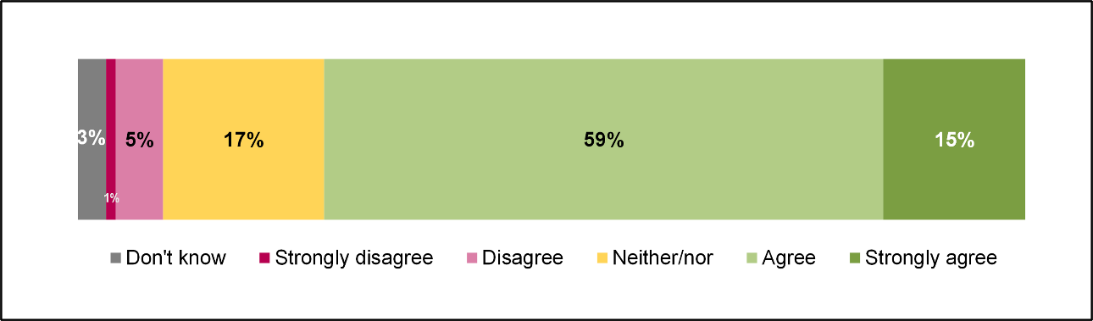
G2.2: To what extent do you agree or disagree with the following statements Capital allowances help with business growth: Base: All (940)
  - Amongst incorporated businesses, those that invested in buildings and structures were more likely to agree (88%). Those that claimed Research and Development Allowances (RDAs) in 2019 to 2020 were more likely to strongly agree (26%). Businesses that claimed the Annual Investment Allowance (AIA) in 2019 to 2020 were more likely to disagree, with roughly one in ten saying it did not help (12%). There were no significant differences by business size. Table 8.1 presents a breakdown of responses by size for incorporated businesses.
Table 8.1 Agreement that Capital allowances help with business growth by business size, incorporated businesses
- | Micro | Small | Medium | Large | All
NET: AGREE | 76% | 71% | 77% | 66% | 74%
NET: DISAGREE | 6% | 10% | 5% | 7% | 7%
G2.2: To what extent do you agree or disagree with the following statements Capital allowances help with business growth: Base: All incorporated businesses (833), Micro (312), Small (179), Medium (217), Large (125).
  - During qualitative interviews some claimants recognised investments that capital allowances were claimed on as enablers of business growth. Some businesses were able to improve productivity and efficiency by investing in new equipment. For example, by upgrading equipment. Some businesses were able to expand as a result of investment. For example, in terms of headcount, premises and product lines. Some businesses reported that investments improved profitability and so are in a better financial position as a result of investment.
“With computers they stop breaking down as much which is a good thing and machinery upgrades, they have better programmes, run smoother and we have less trouble with them … it just made it more efficient.”
Claimant, Manufacturing, Micro
“It has allowed us to expand so in the last two years we have opened two brand new care homes costing together about £20,000,000 … once you get to 60% occupancy you break even and then it gets a bit higher and you earn money so it has allowed us to grow the business.”
Claimant, Health and Social Work, Large
  - The qualitative interviews showed that there were mixed views as to how integral capital allowances were to achieving growth. Many businesses reported that the same investment would have been made regardless of capital allowances. Often businesses noted that the needs of the business drive their decision to invest, and so they would not simply buy for the sake of a capital allowance being available. Some commented that capital allowances were an ‘added bonus’ due to the fact that business requirements remain the same, regardless of available tax relief.
"It's kind of the other way around…the investment needs to be made and the consideration of tax allowances is appertained to that project. It's not that there's a tax break so we should make an investment."
Claimant, Accommodation and Food, Small
  - Other businesses stated that the investments they made would not have been possible without capital allowances or that often the investment would have been to a lesser extent if it weren’t for capital allowances, and therefore capital allowances were key to facilitating growth.
"Because capital allowances provide a way of paying less tax, therefore allowing for more available business funds to be put into investment in equipment."
Claimant, Information and Communication, Micro
  - One business noted that capital allowances enable a level playing field regarding tax relief in certain situations. Capital allowances enable businesses that purchase buildings to receive similar levels of tax relief to those that rent buildings. The respondent noted that without capital allowances, they would simply rent rather than purchase buildings as rent is tax deductible.

Providing a roadmap for capital allowance rates
  - As Figure 8.2 shows, more than four-fifths (63%) of claimant businesses agreed that the Government providing a clear roadmap for capital allowance rates in the future would have a positive effect on the amount they invest (64% incorporated and 57% unincorporated). One in ten businesses (10%) disagreed with the statement (11% incorporated and 7% unincorporated).
Figure 8.2 Agreement that the government providing a clear roadmap for capital allowance rates in the future would have a positive impact on business investment amounts
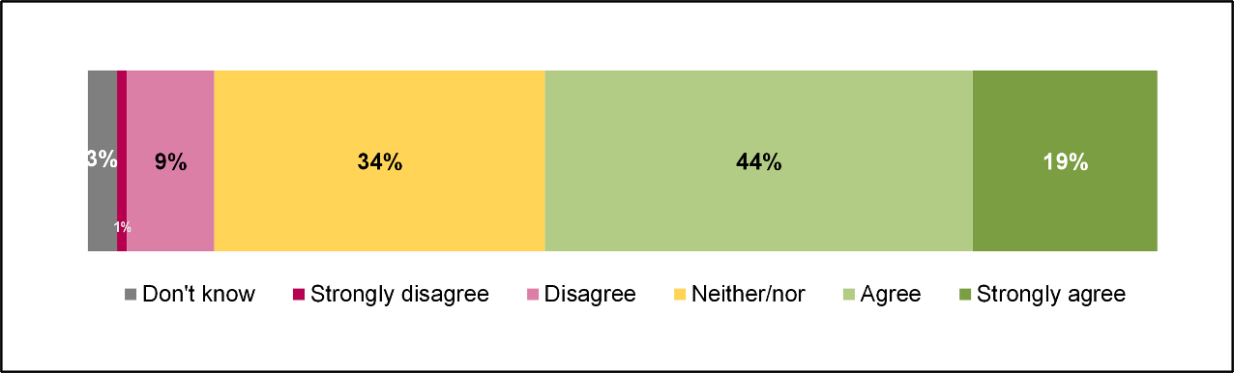
G2.5: To what extent do you agree or disagree with the following statement: The Government providing a clear roadmap for capital allowance rates in the future would have a positive impact on the amount my business invests. Base: All (940)
  - Businesses who invested in buildings and structures (77%), building fixtures and fittings (71%), and cars (78%) were more likely than average to agree with the statement. Large investors (£500,000+) were also more likely to agree than average, with over eight out of ten businesses agreeing (83%).

Appendix

  - The achieved survey sample of incorporated claimants was weighted to make it representative of the underlying population in terms of size and sector. It was not possible to weight the achieved survey sample of unincorporated claimants due to insufficient information about the characteristics of this group. Consequently, Table 9.2 presents whether claimants invested in second hand assets and the proportion of investment spend on such assets by size for incorporated businesses only.
Table 9.1 Value of investments made by claimants by asset type
- | Base | Don’t Know/Refused | Under £5,000 | £5,000-£9,999 | £10,000-£24,999 | £25,000-£49,999 | £50,000+
All businesses that could recall investments made | 875 | 23% | 30% | 8% | 14% | 10% | 14%
Construction plant | 86 | 43% | 7% | 3% | 22% | 5% | 19%
Buildings and structures | 138 | 52% | 7% | 2% | 15% | 4% | 18%
Vans and lorries | 211 | 29% | 4% | 5% | 29% | 19% | 13%
Machinery and tools | 425 | 32% | 31% | 11% | 11% | 6% | 9%
Building fixtures and fittings | 338 | 42% | 23% | 11% | 10% | 3% | 10%
IT Software | 328 | 33% | 51% | 5% | 5% | 2% | 3%
Cars | 158 | 33% | 13% | 11% | 18% | 13% | 11%
IT Equipment | 625 | 26% | 54% | 9% | 7% | 1% | 2%
Office Equipment | 450 | 31% | 59% | 5% | 2% | 1% | 1%
B2: How much did your business spend on the following assets? Base: All who can recall investments made (see table).

Table 9.2 Whether businesses invested in second hand assets and proportion of investment spent by size, incorporated businesses
- | Micro | Small | Medium | Large | All
Business invested in second-hand assets: YES | 13% | 14% | 10% | 11% | 13%
19% or less | 33% | 18% | 27% | 60% | 30%
20-59% | 25% | 14% | 45% | 7% | 22%
60% or more | 40% | 50% | 9% | 17% | 41%
Don’t know | 2% | 17% | 18% | 15% | 7%
B5: Did the plant and machinery eligible for CA that your business invested in include second-hand assets? Base: All incorporated businesses who can recall investments made (789), Micro (289), Small, (170), Medium (211), Large (119). B6: What proportion of the total invested in plant and machinery eligible for CA was spent on second hand assets? Base: Incorporated businesses who invested in Second hand assets (106), Micro (34), Small (32), Medium (25), Large (15).

“

I” “Research illuminates the world for organisations businesses and individuals helping them to make better-informed decisions.”

Our Values:

1. Being human first:
Whether employer or employee, client or collaborator, we are all humans first and foremost. Recognising this essential humanity is central to how we conduct our business, and how we lead our lives. We respect and accommodate each individual’s way of thinking, working and communicating, mindful of the fact that each has their own story and means of telling it.

2. Impartiality and independence:
IFF is a research-led organisation which believes in letting the evidence do the talking. We don’t undertake projects with a preconception of what “the answer” is, and we do not hide from the truths that research reveals. We are independent, in the research we conduct, of political flavour or dogma. We are open-minded, imaginative and intellectually rigorous.

3. Making a difference:
At IFF, we want to make a difference to the clients we work with, and we work with clients who share our ambition for positive change. We expect all IFF staff to take personal responsibility for everything they do at work, which should always be the best they can deliver.

It is worth noting that businesses claiming at least £1 million of capital allowances account for 1% of businesses claiming allowances, but account for around 80% of all capital allowance claimed (see Corporation Tax Statistics 2022 - GOV.UK (www.gov.uk) (Tables 12A and 12B)
These averages are based on survey responses from 20 claimant businesses that reported bringing investments forward in response to the introduction of the Super-Deduction, were able to supply the total value of investments that qualified for the Super-Deduction in 2019/20 and were able to supply the proportion of total investment that was brought forward as a result of the Super-Deduction. Given the low base, these averages should be treated with caution.
These averages are based on survey responses from 10 claimant businesses that reported making investments that were previously unplanned in response to the introduction of the Super-Deduction, were able to supply the total value of investments that qualified for the Super-Deduction in 2019/20 and were able to supply the proportion of total investment that was only made as a result of the Super-Deduction. Given the low base, these averages should be treated with caution.
These averages are based on survey responses from 11 claimant businesses that reported investing a higher amount in assets in response to the introduction of the Super-Deduction, were able to supply the total value of investments that qualified for the Super-Deduction in 2019/20 and were able to supply the proportion of total investment that was additional spend on investments already planned for 2021/22 made as a result of the Super-Deduction. Given the low base, these averages should be treated with caution.

